Heugh Battery Project.

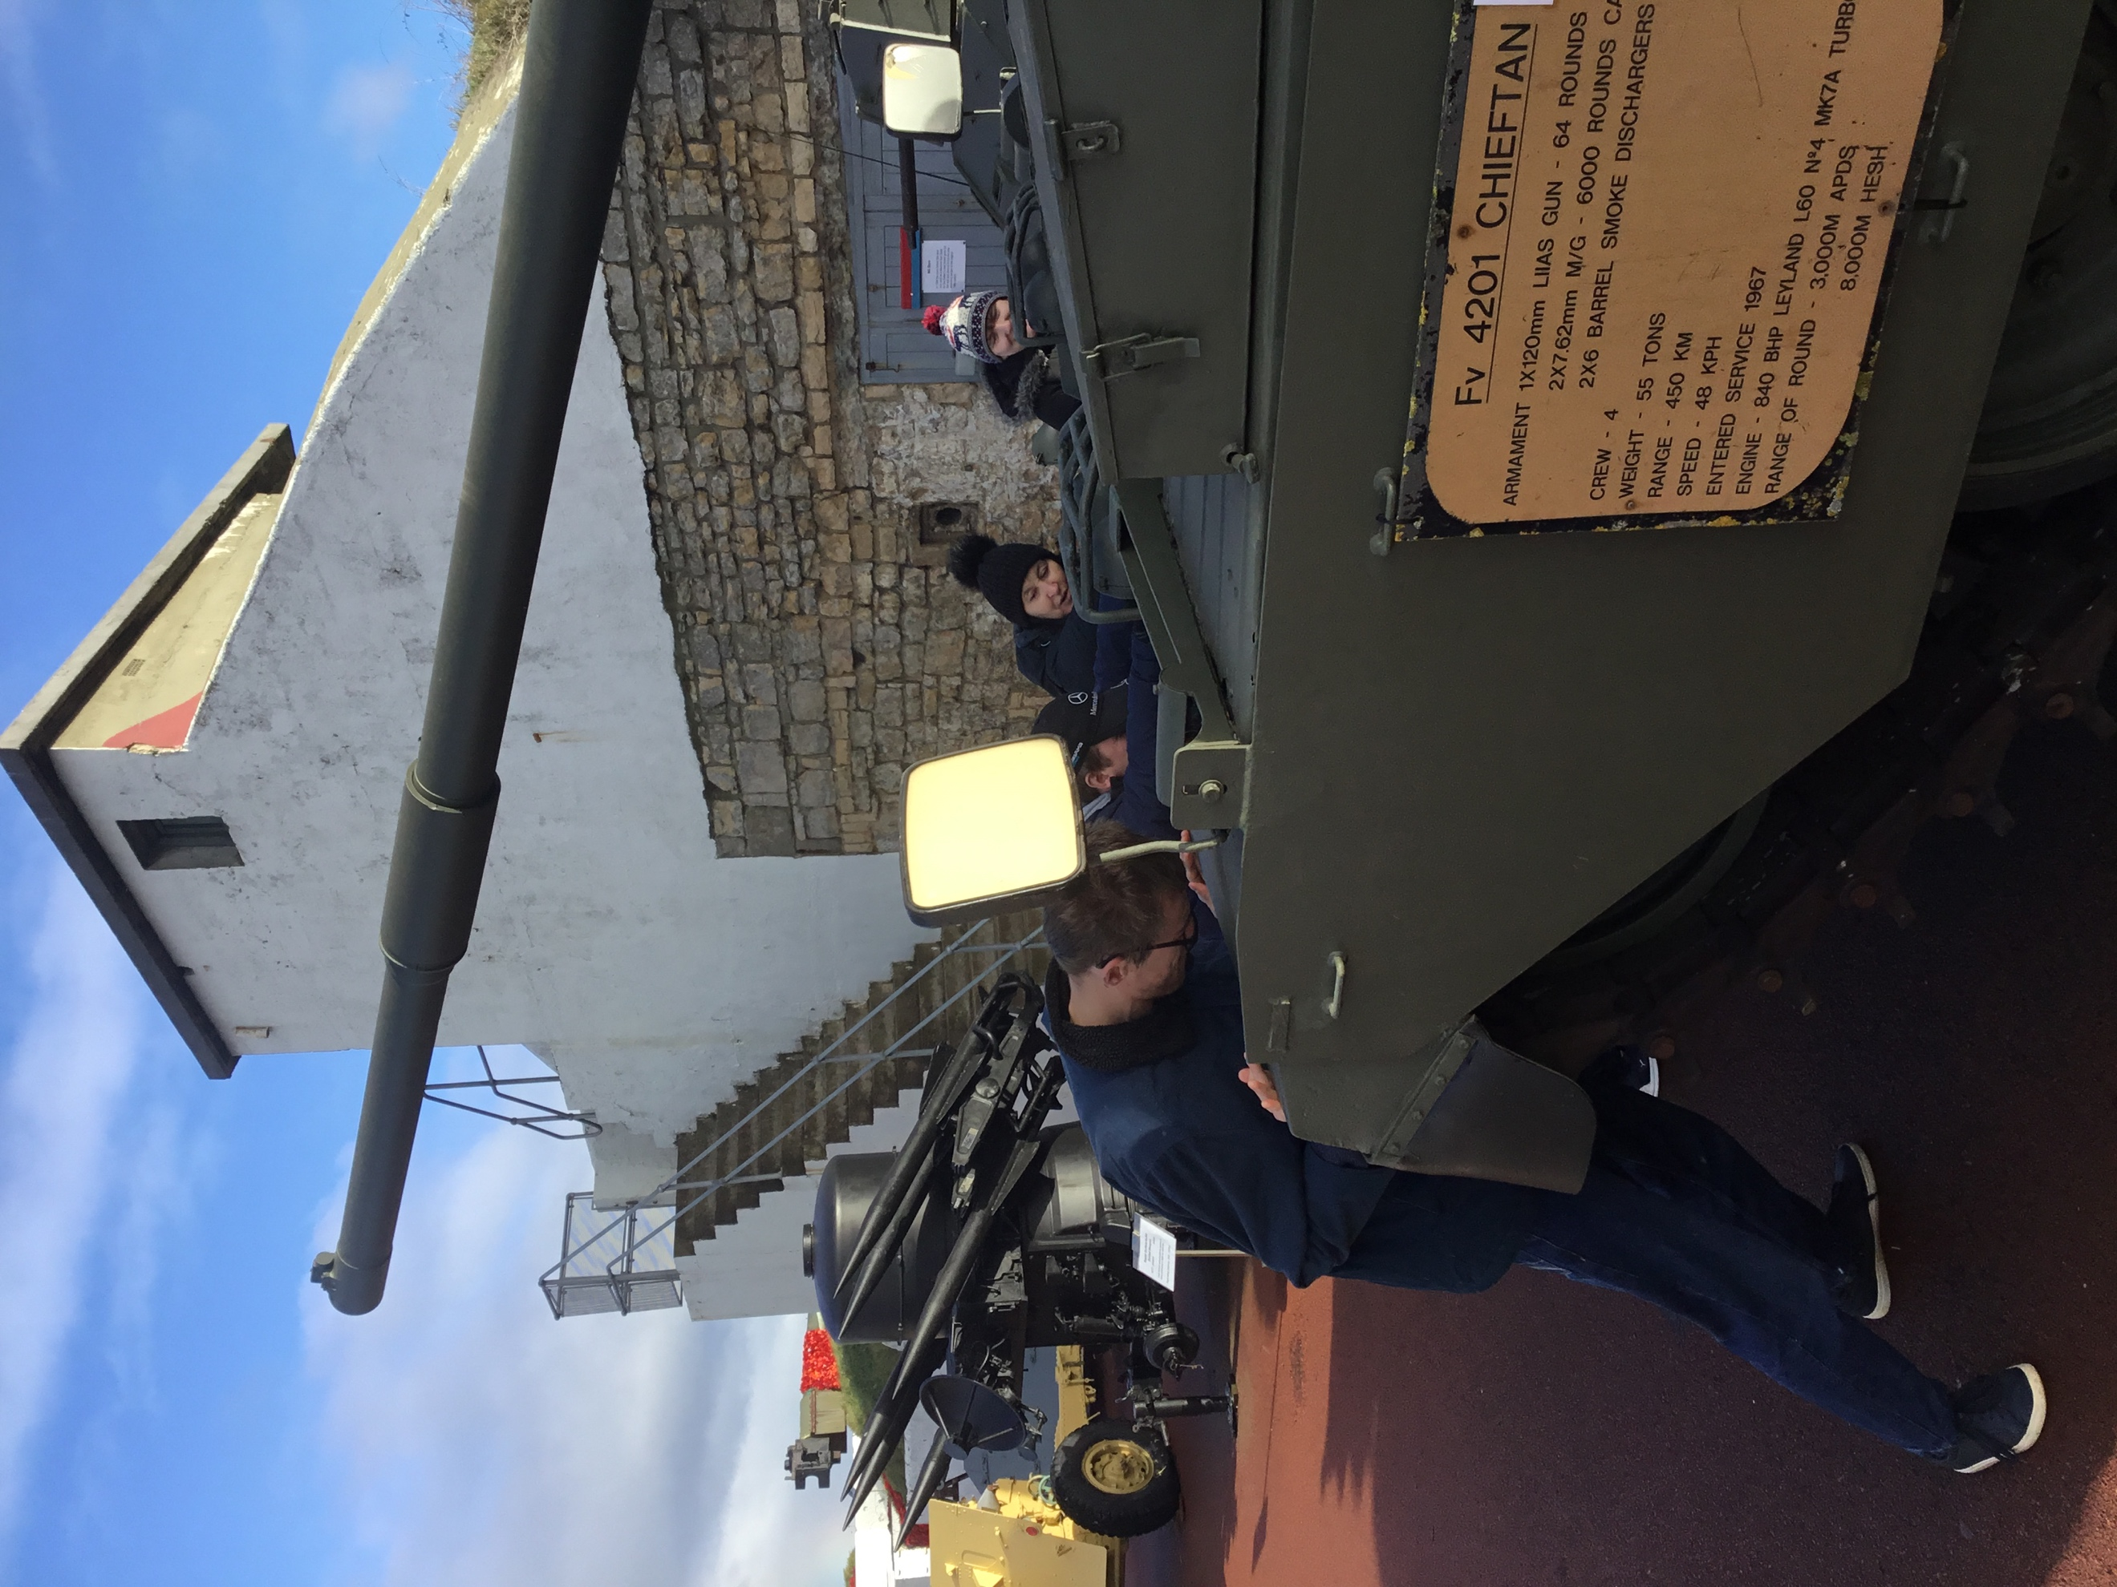
This term a group of learners from Catcote Futures have been working with the Heugh Battery Museum, working around World War 1 and careers available in the museum sector. The learners have taken part in sessions in college, had visitors in from the Heugh Battery Museum and been on visits out.

The class has really enjoyed learning about life during WW1, looking at what this was, what life was like in the trenches and what jobs would have been available at the time. They have then also looked at what roles may be needed in a museum, and begun discussions about what they would enjoy to do and what skills these roles would need. When visiting the Museum, they then got to see the roles in action while having a tour around the museum and the café. This also gave them a good understanding of the difference in jobs and life between WW1 and now, realising how Hartlepool has changed.

The learners also took part in Remembrance Day, going to the Cenotaph on 11th November to hold a 2 minute silence, and then some learners took part in the Remembrance day parade on Remembrance Sunday as well.

We hope to continue on this link and work towards a take-over day, with the learners getting the chance to work in the museum itself. This has been a brilliant opportunity to build their confidence, communication skills and experience different working environments.

