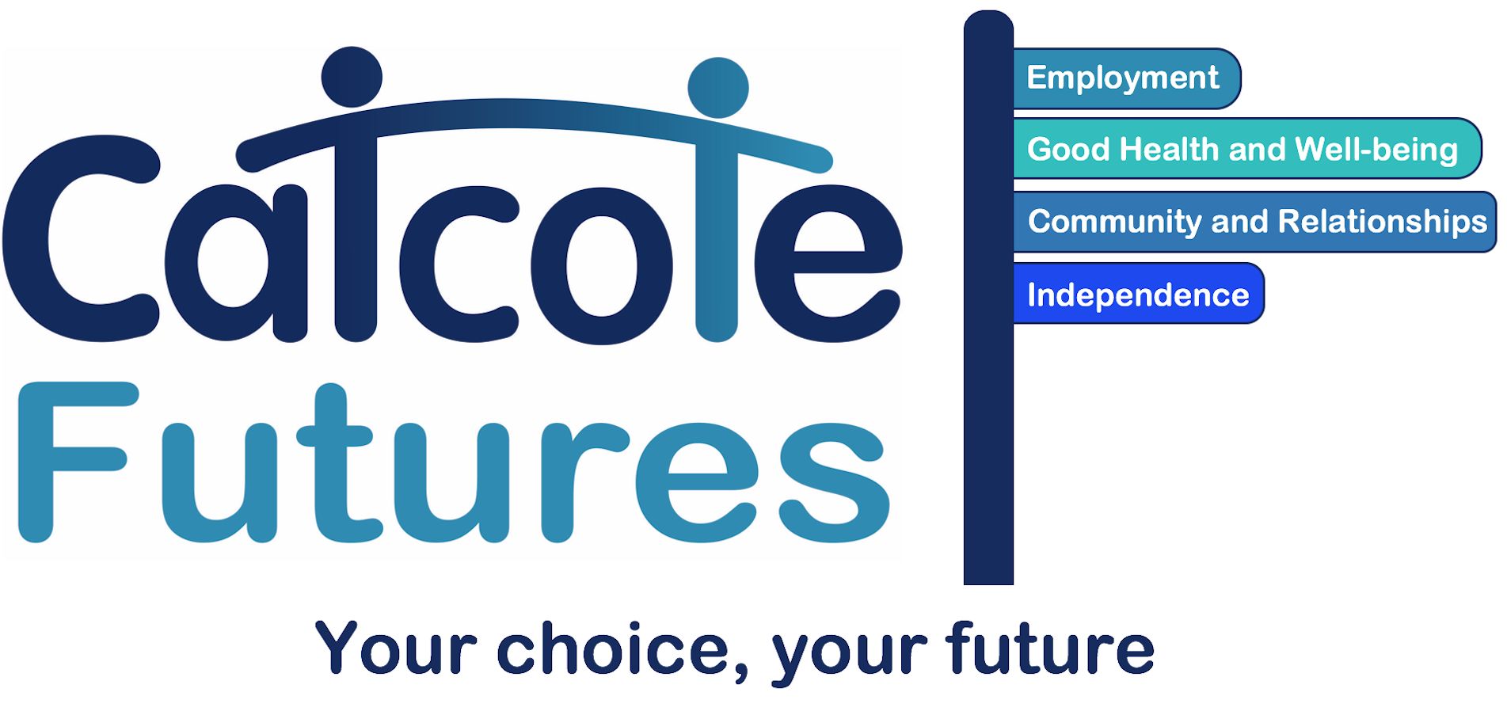
Catcote Futures Careers Events Calendar

 | Sensory Explorers | Aiming  High | Reaching  Out | Taking the Lead | Steps
Aut 1 |  |  |  | This is Me  Guest Speaker | Tutorial (Job coaches)  Guest Speaker
Aut 2 | Dropdown Days | Dropdown Days | Dropdown Days  Internal Takeover Day | Dropdown Days  Takeover Day  Inclusive Skills | Tutorial (Job coaches)  Vocational Profile  Dropdown Days
Spr 1 |  |  | Choices Event | This is Me  Guest speaker  Choices Event | Tutorial (Job coaches)  Guest speaker  Choices Event
Spr 2 |  |  | Encounters with FE  Internal Takeover Day | Encounters with FE  Takeover Day | Tutorial (Job coaches)  Encounters with FE
Sum 1 |  |  |  | This is Me  Careers Interview  (Vocational Profile)  Guest speaker | Tutorial (Job coaches) Careers Interview  Guest speaker
Sum 2 | Dropdown Days | Dropdown Days | Dropdown Days | Dropdown Days (Job Interviews) | Tutorial (Job coaches)  Mock interviews  Dropdown Days

