Careers Offer Across Our Pathways

CAr
STEPs Programme Offer
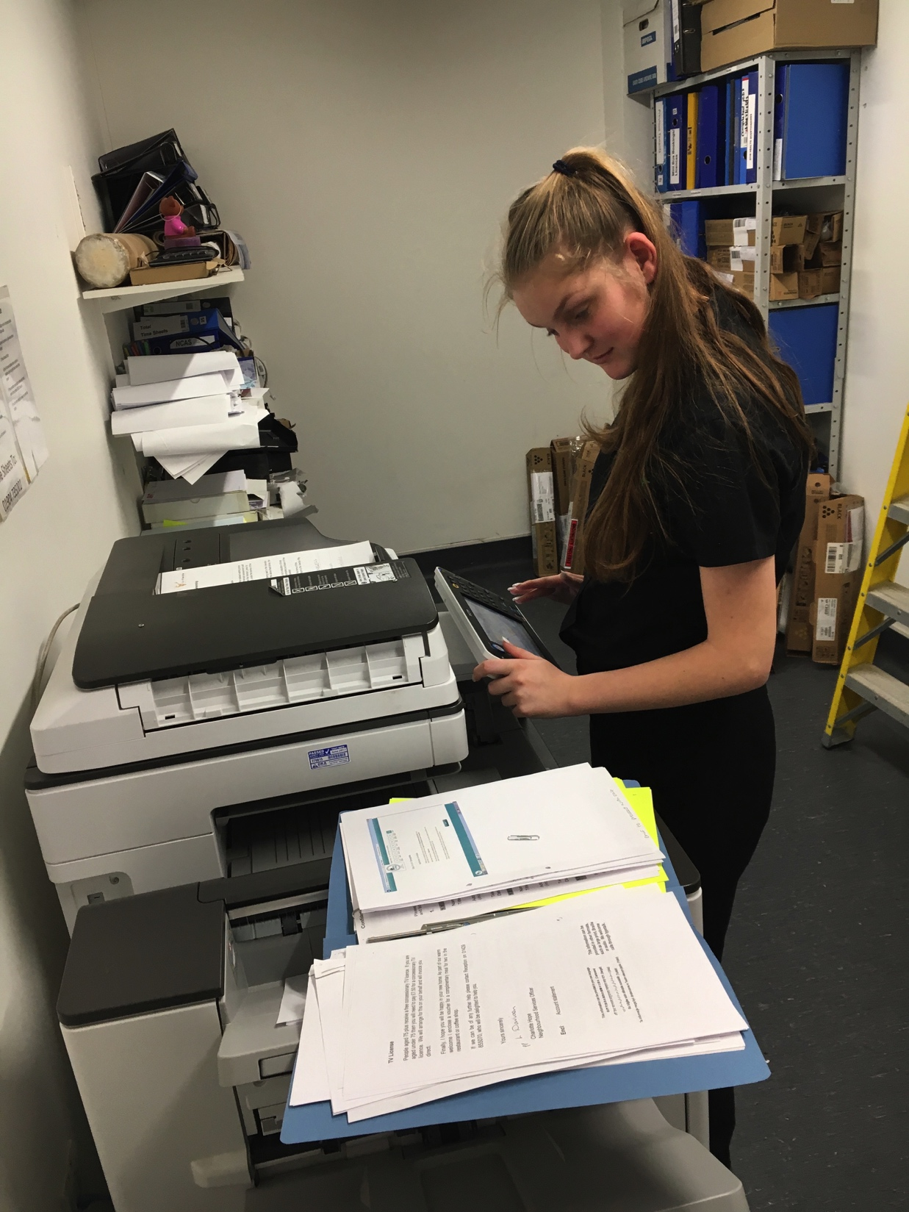
* (Employment Training Hub located in Middleton Grange Shopping Centre.)

Aim: To develop transferable work skills through real work environments leading to internal or external supported internships and paid employment.

We offer…

Dedicated Employability Lessons:
- Personal safety.
- Knowing your local area.
- Managing personal finance.
- Working with others.
- PREVENT.
- Getting about safely.
- Self-Regulation.
- Functionality.
- Interviews.
- Applying for jobs.
- References and CV building.

Internal Work Placements.
- Retail (Metro.)
- Hospitality and Catering (Caravan, Kitchen.)
- Gardens and Maintenance (Site Services.)
- Administration and Reception (Corporate Services.)
- Job Shadowing.
- Classroom support.
- Access to dedicated job coach support (TSI trained.)

External Work Placements (personalised to skill sets and aspirations)
- Links to over 70 employers from McDonalds to Premier Inn (see Website for details.)
- Person centred placements range from half a day to four days, per week.
- Access to dedicated job coach support (TSI trained.)
- Retail and Catering (Catcote Metro and Vestry Café)

Careers interview/CEIAG
- Access to a qualified careers advisor weekly.
- Annual careers interview with qualified careers advisor.
- Annual vocational profiling with careers assistant.
- Half termly tutorial with job coaches.

Independent Travel Training
- Road safety skills
- Using public transport
- Money
- Safety in the community

Working Hart Project
- Half termly carousel of work experience within:
  - Catering
  - Hospitality
  - Admin and Reception
  - Groundwork and maintenance
  - Retail

Encounters with Employers
- Guest speakers
- Mock interviews

Collapsed Careers and Enterprise Days
- Two per year (Autumn & Summer)

Encounters with FE providers
- Project Choice
- Taster days at other colleges
- Choices board
- Careers fayres

CORRECT skills
- Embedded throughout
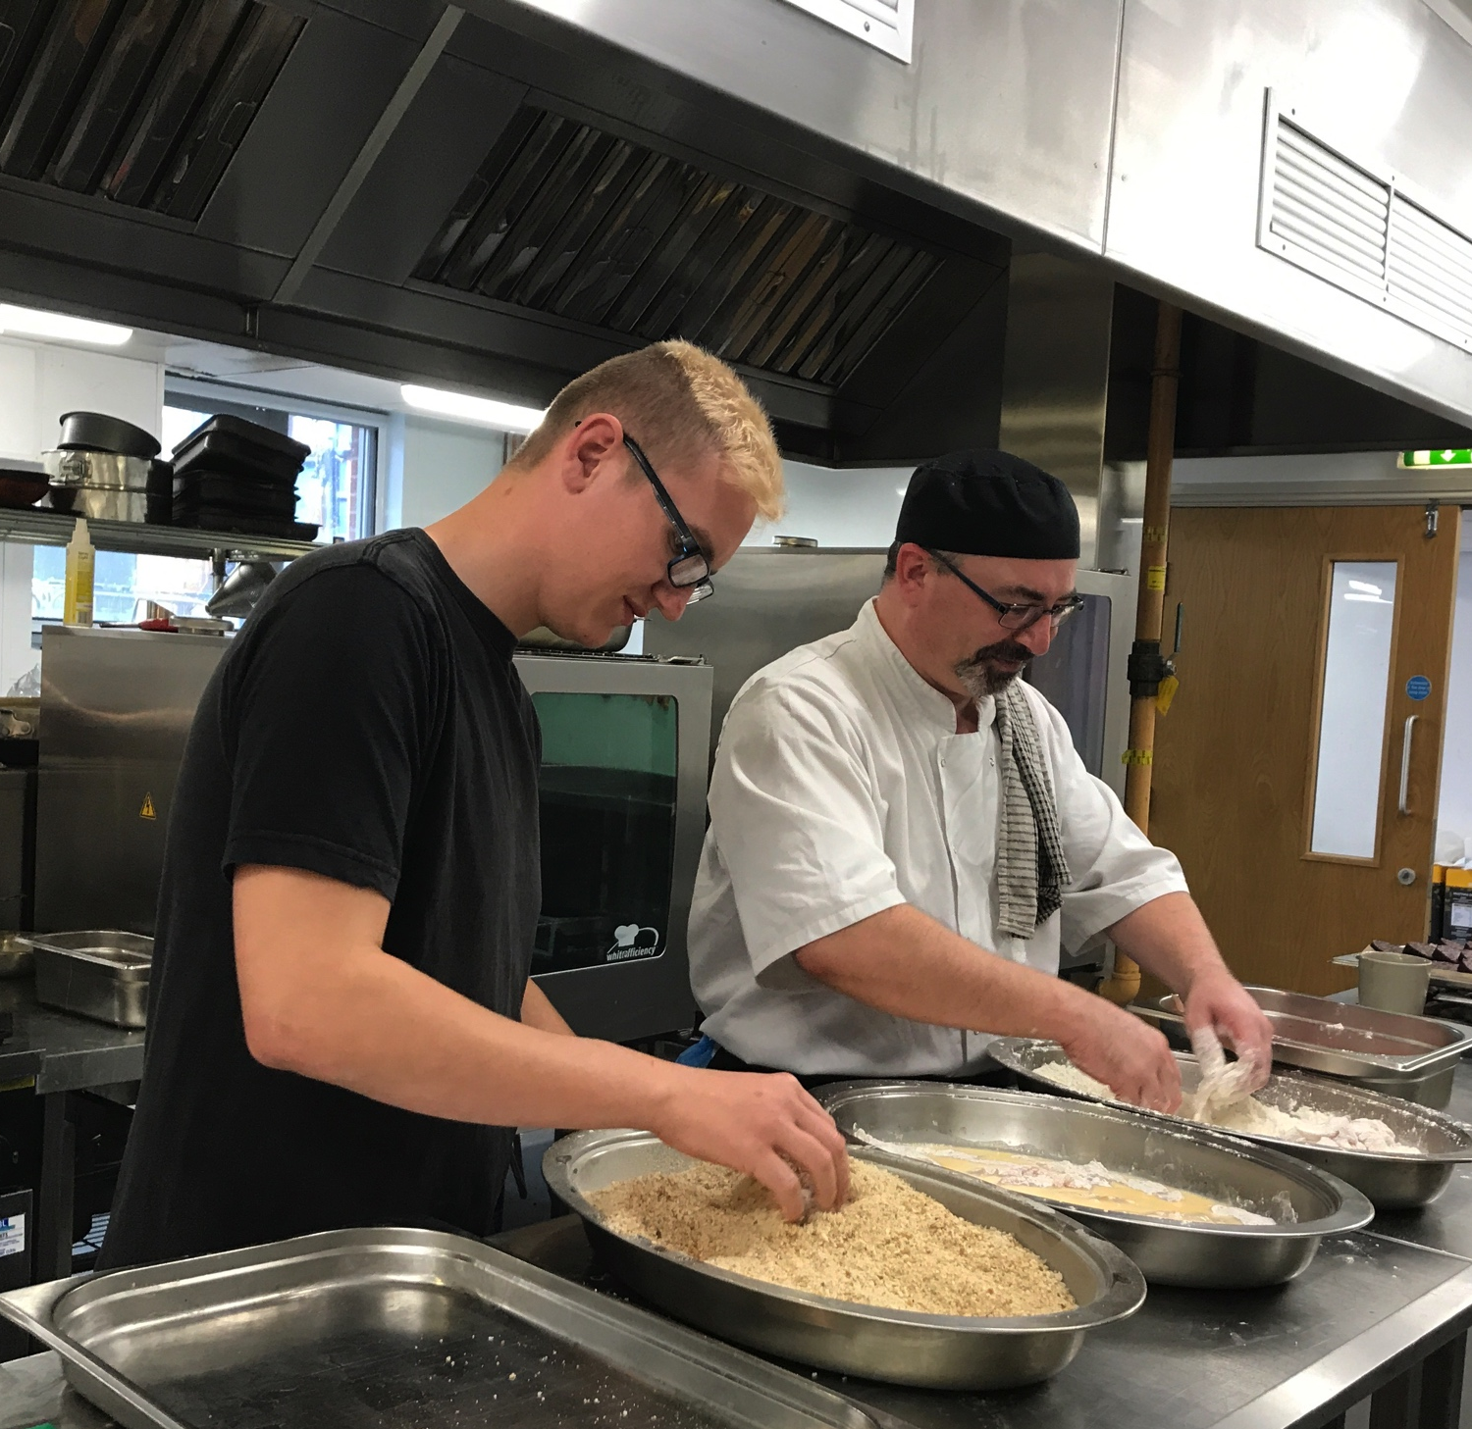

Taking the Lead Programme Offer

To develop vocational skills, leading to supported or voluntary work placements.

Employability and vocational lessons (NOCN)
- Applying for Jobs and Courses;
- Induction to work;
- Carrying out a Practical Activity in the Workplace.
- Following instructions in the workplace.
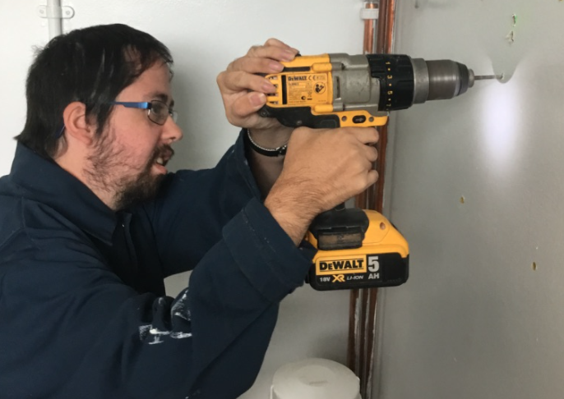
- Health and Safety Procedures in the Workplace.
- Making Career Choices.
- Careers at Every Level pilot Sept 2021.

Access to Internal Specialist Vocational Areas
- Hair and Beauty Salon
- Horticulture
- Reprographics Studio
- Media Studies
- Bistro
- Hospitality (Caravan)
- Ceramics Workshop
- Retail and Catering (Catcote Metro and Vestry Café)

Internal Work Experiences
- Retail
- Hospitality and Catering (Vestry, Caravan, Bistro, Kitchen.)
- Gardens and Maintenance (Site Services.)
- Administration and Reception (Corporate Services.)
- Job Shadowing.
- Classroom support.

External Work Placements (personalised to skill sets and aspirations)
- Links to over 70 employers from McDonalds to Premier Inn (see Website for details.)
- Person centred placements range from half a day to four days, per week.
- Retail and Catering (Catcote Metro and Vestry Café)

Supported and independent external work placements & experiences.
- Links to over 70 employers from McDonalds to Premier Inn (see Website for details.)
- Person centred placements range from half a day to one day per week.

CIAG (including impartial interview)
- Access to two qualified careers advisors weekly.
- Annual careers interview with qualified careers advisor.
- Annual vocational profiling with careers assistant.
- Ongoing personalised tutorial conversation (This is me) Ali

Dedicated and embedded Enterprise skills
- Mini-Enterprise projects across the year.
  - Christmas Enterprise Drive
  - Resin signs
  - Dog biscuits
  - Coasters
  - Truffle Enterprise
  - Hampers
  - Sausage and Bacon Sandwiches
  - Catering Enterprise

- Weekly enterprise lessons

Travel Training
- Road Safety Skills
- Safer pedestrian Skills
- Using Public Transport

Termly Employer Visits & Encounters
- Guest speakers
- Mock interviews
- Takeover days (HCFE Flagship Restaurant)

Collapsed Careers and Enterprise Days
- Two per year (Autumn & Summer)

Encounters with other FE providers (where appropriate:)
- Inclusive skills competition
- Visits to other colleges
- Choices board
- Careers fayres

Working Hart Project
- Half termly carousel of work experience within:
  - Catering
  - Hospitality
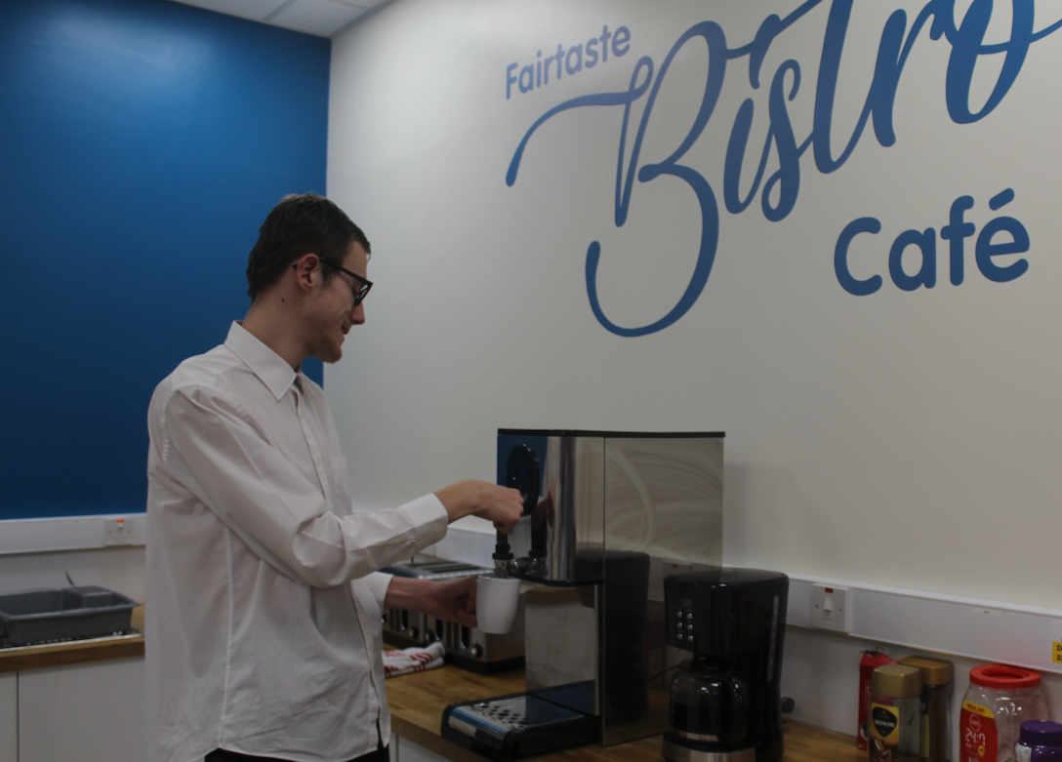
  - Admin and Reception
  - Groundwork and maintenance
  - Retail

CORRECT/Enterprise skills
- Embedded throughout

Reaching Out

To follow personalised programmes to enable learners to pursue their individual interests and strengths, around the world of work.

Employability and vocational lessons with a focus on social communication and emotional regulation:
- Building confidence and self-esteem;
- Looking and acting the part in the workplace;
- Reading and writing keywords in the workplace;
- Using communication skills in the workplace;
- Applying for Jobs and Courses;
- Working with Others;
- Carrying out a Practical Activity in the Workplace.
- Following instructions in the workplace.
- Health and Safety Procedures in the Workplace.
- Careers at Every Level pilot Sept 2021.

Supported and independent internal and external work placements & experiences.

Internal:
- Hospitality and Catering (Vestry, Caravan, Bistro, Kitchen.)
- Gardens and Maintenance (Site Services.)
- Job Shadowing.

External:
- Links to over 70 employers from McDonalds to Premier Inn (see Website for details.)
- Person centred placements range from half a day to four days, per week.
- Retail and Catering (Catcote Metro and Vestry Café)
- Hartlepool Special Needs Group
- Lindisfarne Care Home
- Catcote Vestry Café
- Catcote Metro

Dedicated and embedded Enterprise skills:
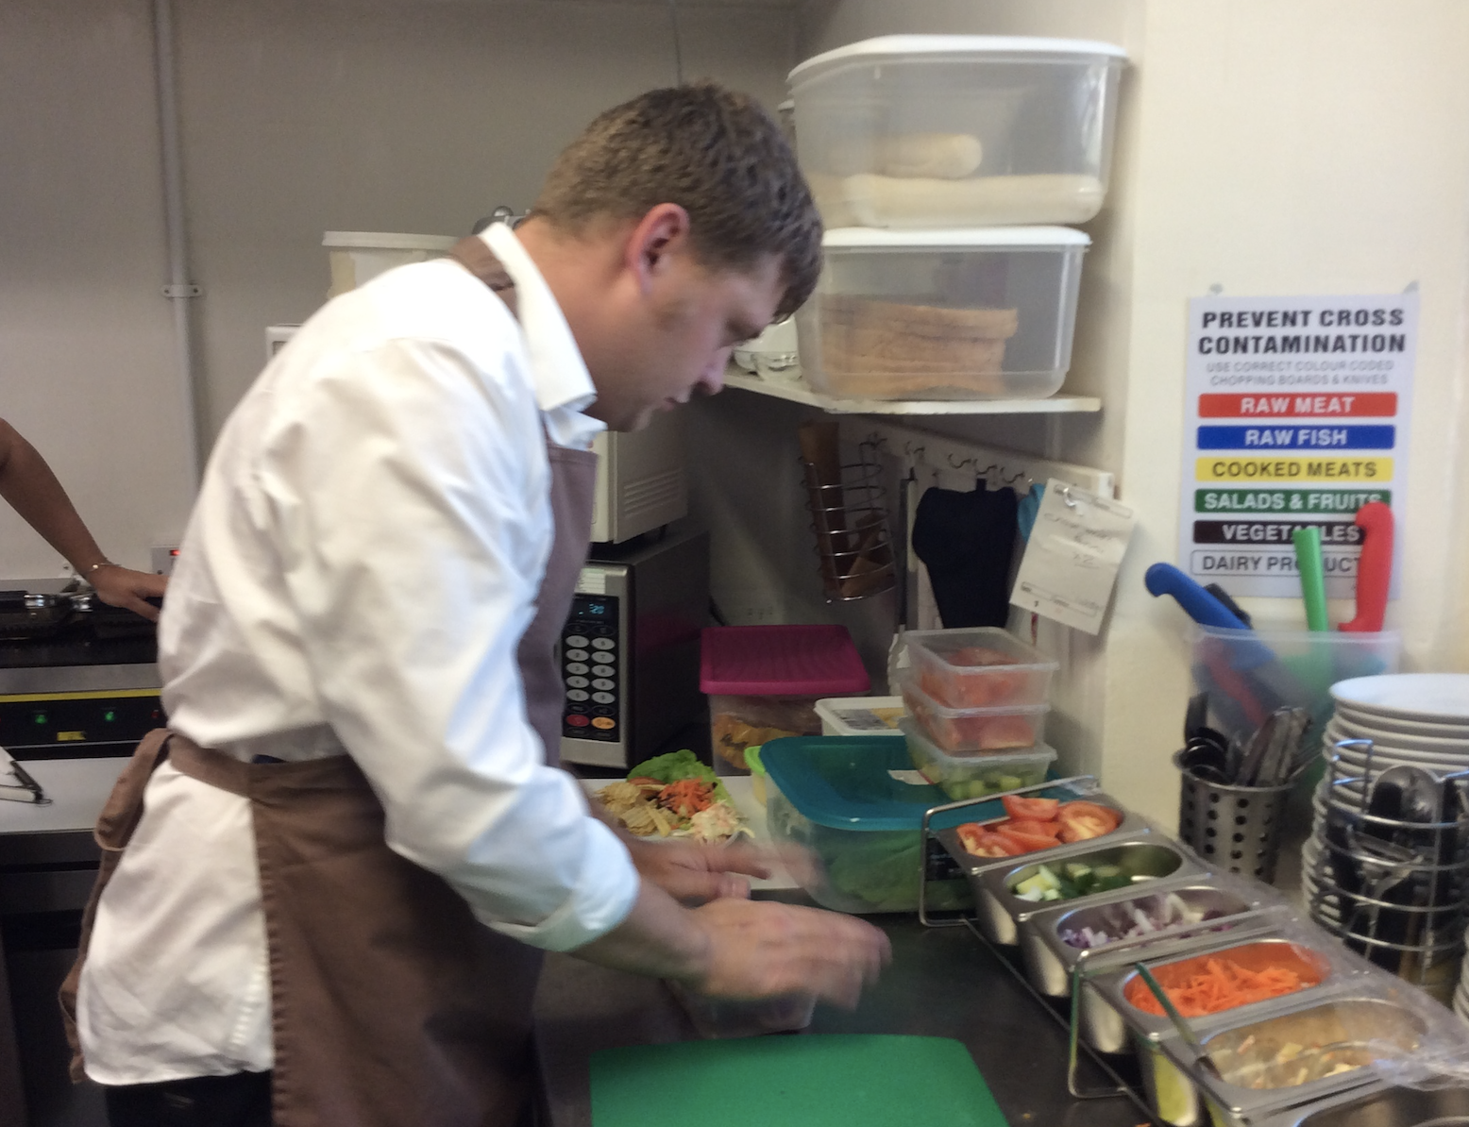
- Mini-Enterprise projects across the year.
  - Christmas Enterprise Drive
  - Hampers
  - Sausage and Bacon Sandwiches
  - Catering Enterprise

External visits to places of employment
- Costa Project

Internal Takeover Days
- Bistro
- Ground staff

Collapsed Careers and Enterprise Days
- Two per year (Autumn & Summer)

Encounters with other FE providers (where appropriate:)
- Access to information about other provision (e.g. Families First)
- Choices board
- Careers fayres

CORRECT/Enterprise skills.
- Embedded throughout

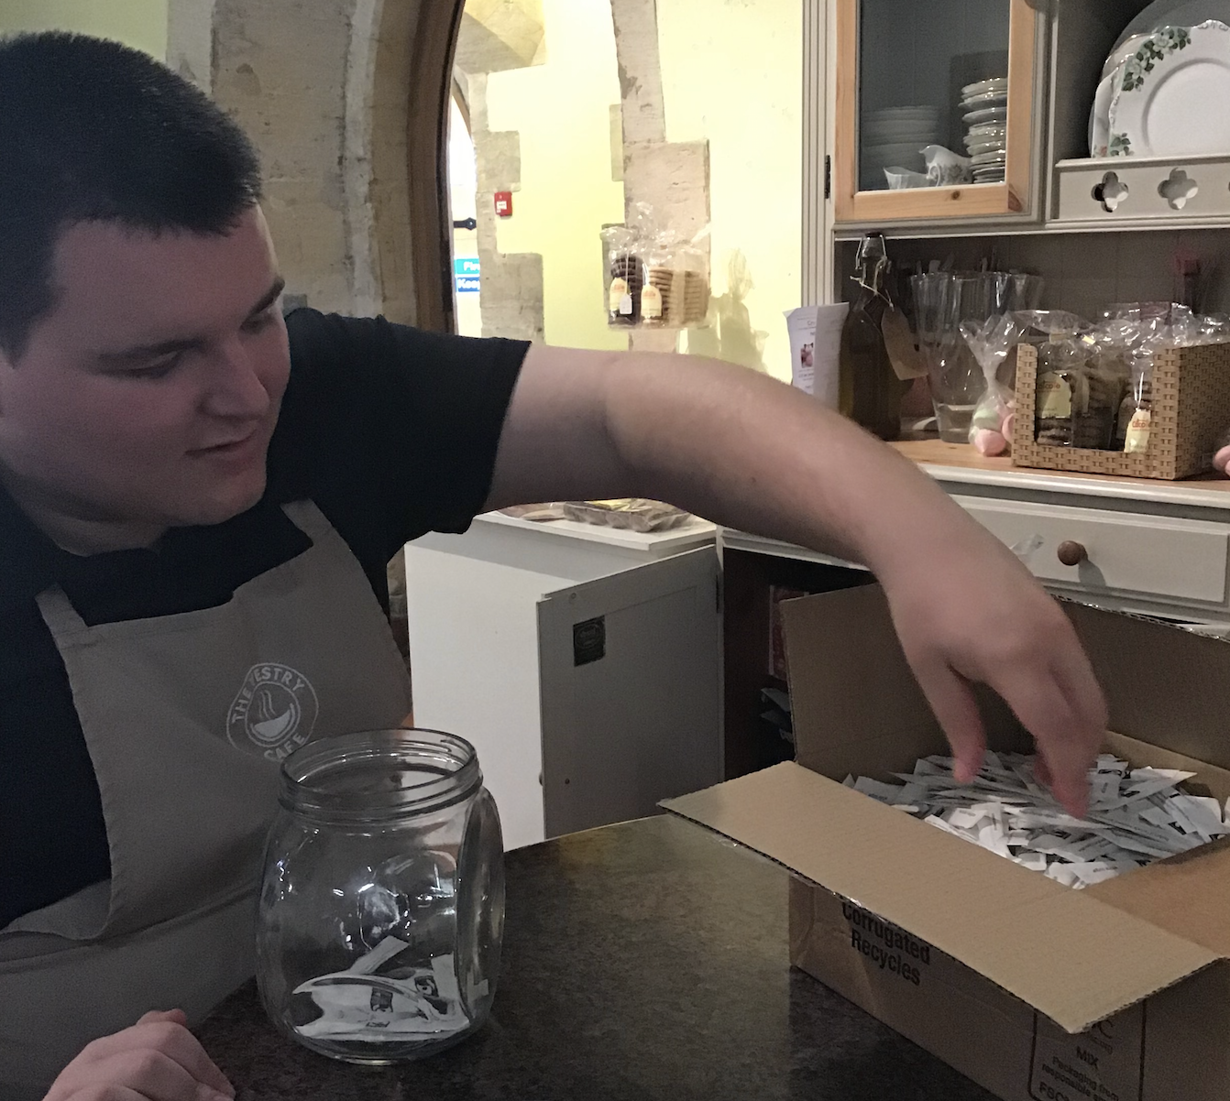
Aiming High

To develop and apply core cognitive skills in a wider range of pre-vocational contexts.

Employability and vocational lessons with a focus on the pre-skills for work (e.g. functional skills, following instructions, routines, emotional regulation and transition: )

- Developing skills for the workplace: following instructions
- Participating in a mini-enterprise project
- Early mathematics: sequencing and sorting
- Interacting purposefully with ICT

Supported Internal work placements & experiences.
- Laundry
- Table setting
- Salon
- Admin

Enterprise projects
- Ice Cream Project
- Christmas Tree Project
- Car Washing Project

Experiential visits to places of employment
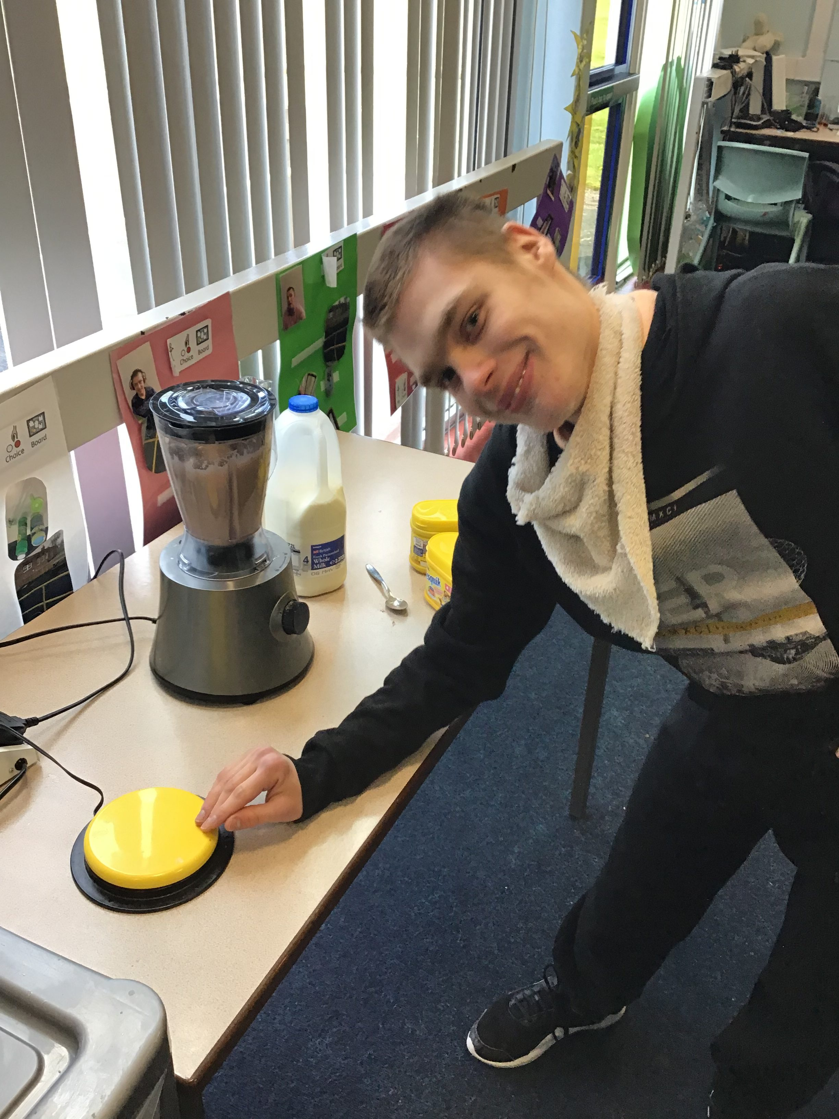
- Supermarkets, café’s etc.

Collapsed Careers and Enterprise Days
- Two per year (Autumn & Summer)

10 Enterprise Commandments.
Embedded Throughout.

Sensory Explorers

To purposefully engage in a range of sensory experiences to further develop sensory motor skills.

Vocational programmes and experiences with a focus on sensory education, cause and effect communication and engagement.
- Responding to ICT enabled equipment
- Participating in a mini-enterprise project
- Using creative software
- Selecting and using cooking equipment

External visits to places of employment
- Supermarkets, cafes, garden centres.

Enterprise projects
- Truffle Project
- Coaster Project
- Dog Biscuit

Collapsed Careers and Enterprise days

10 Enterprise Commandments.
- Embedded throughout.

