Travel Training
Chloe has completed the first stage of her travel training to journey to and from college independently. Chloe has been fully supported by her Job Coach Sue Currell, to be able to walk to the bus stop, select the correct bus, pay for her ticket and stop the bus at the correct bus stop. Chloe has worked so hard during the last 6 weeks that she is ready to begin stage 2, which is to complete her journey independently whilst the job coach follows her discreetly in the car.
Chloe is very proud of her achievement as are her staff team at STEPS!!! Well done Chloe!
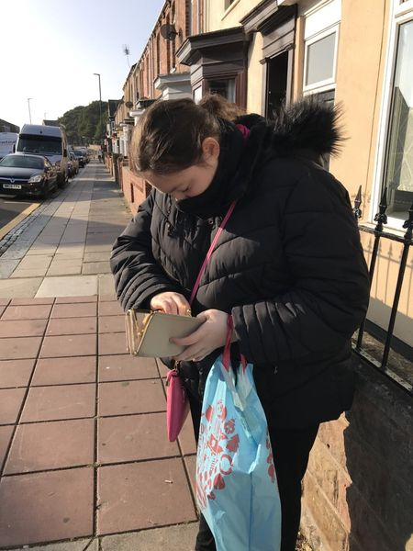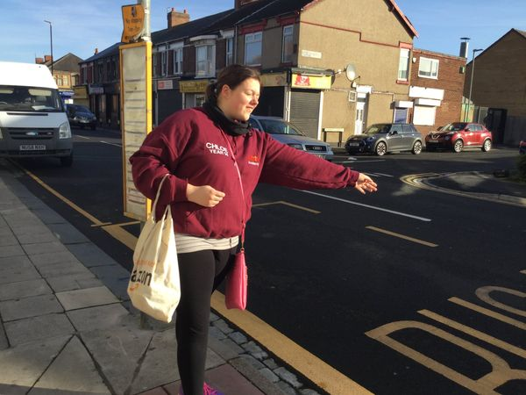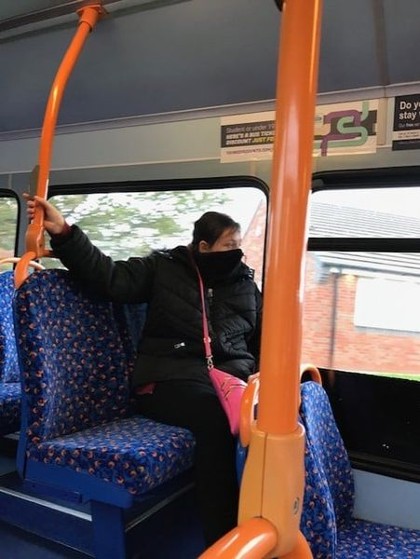

+3

