The Cogfather
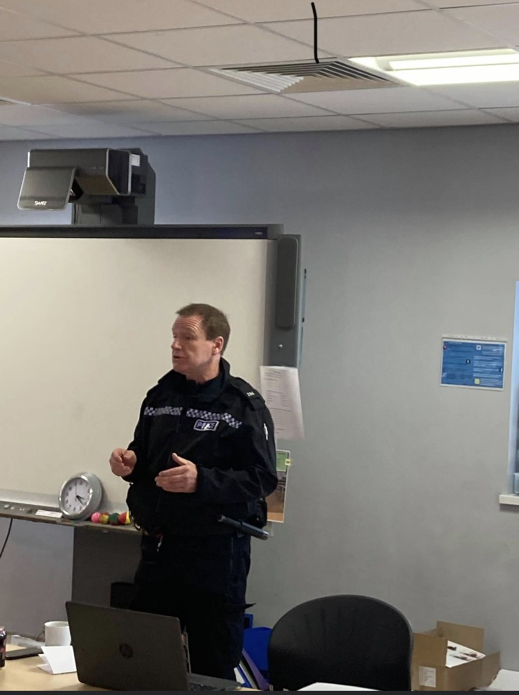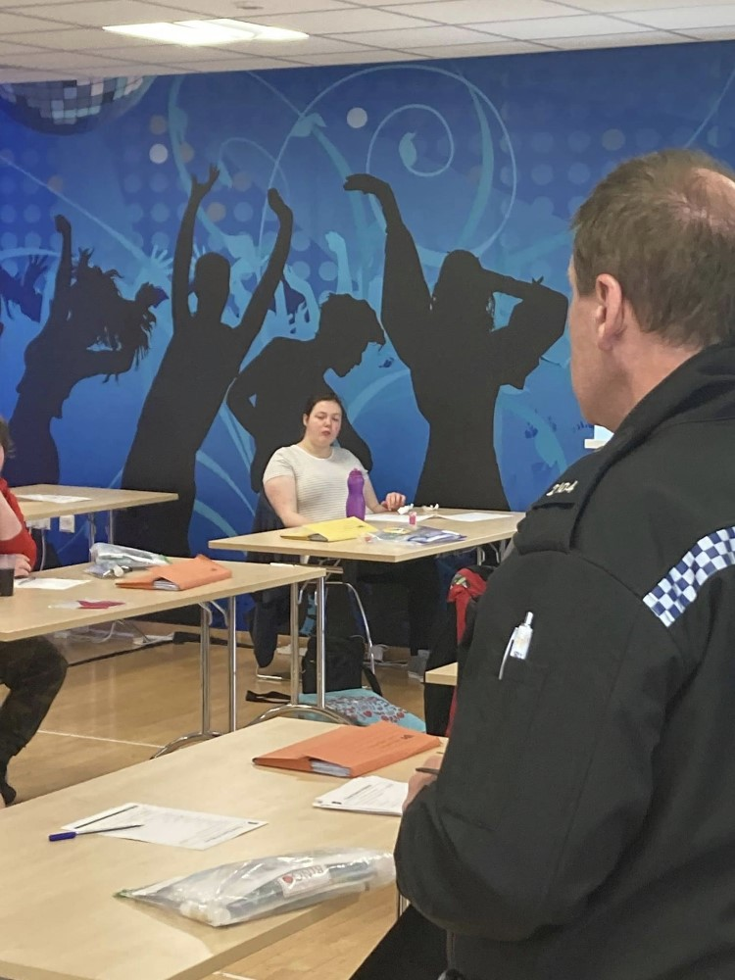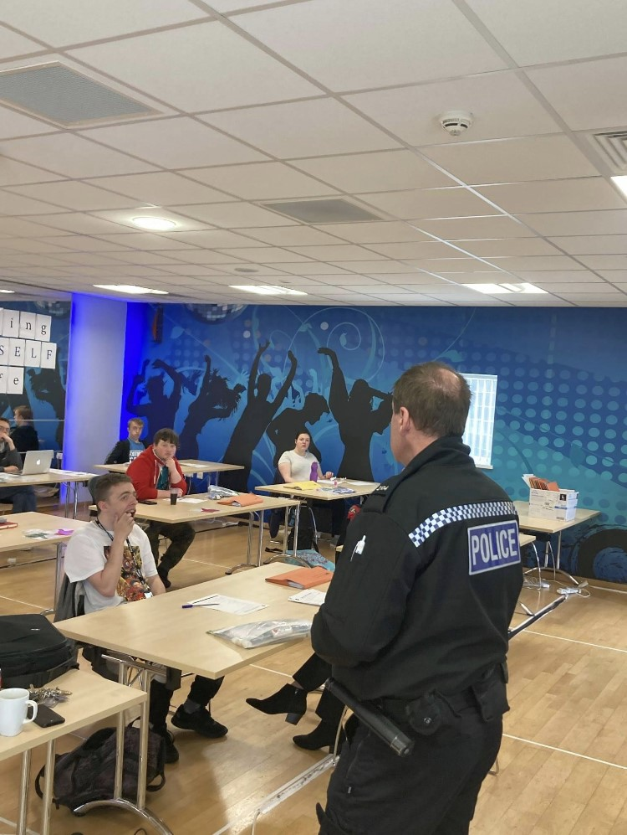

As part of the Careers and Enterprise week with Tees Valley Combined Authority PC Coggin talked to students as they were taking part in a CSI challenge. He also called in to talk to STEPS students about job roles in the police force.
The students really enjoyed his visit and are looking forward to visiting Hartlepool Police Station and taking part in a ‘ride along’ to experience ‘real’ life police work first hand!
Thank you PC Coggin aka The Cogfather!

