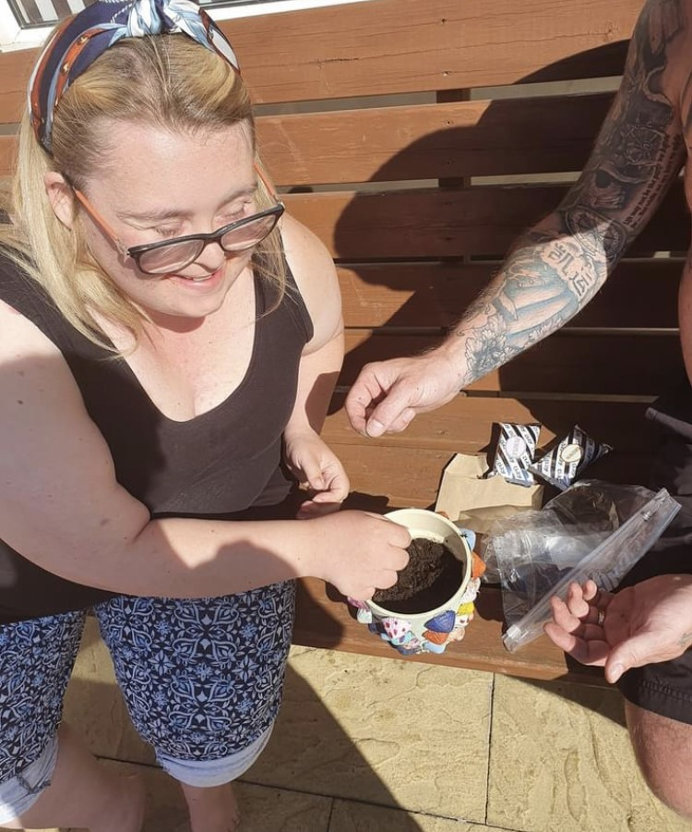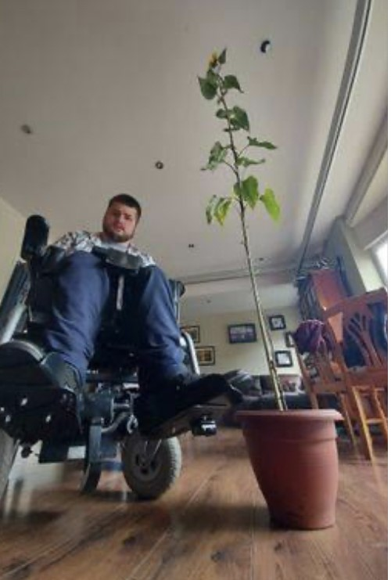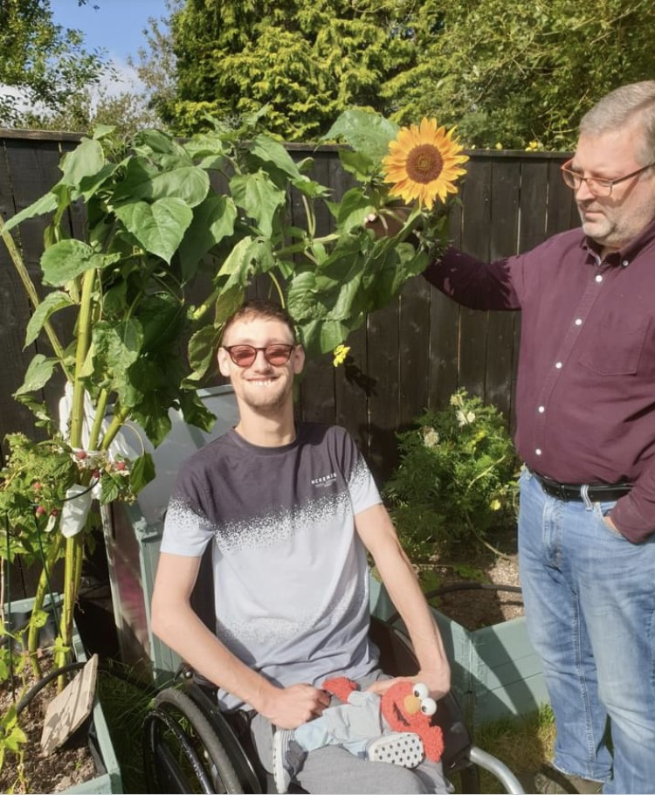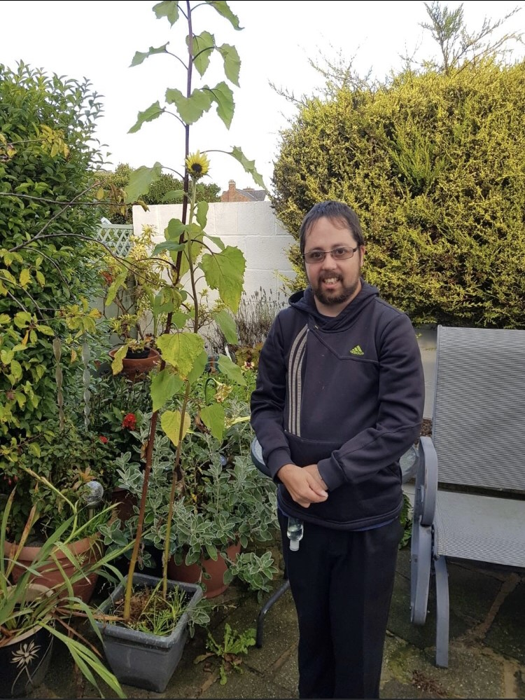

Alan Titchmarch may have competition!
Horticulture plays a large part in the curriculum at Catcote Futures with students across all pathways developing their knowledge, skills and experience, and what better way to demonstrate these than a “Sunflower Challenge"
In May 2020 students at Catcote Futures were excited to receive their work packs and find enclosed a “Sunflower Challenge”. Students read their instructions and carefully potted, planted and watered their seeds. Students continued to care for their sunflower seeds and helped them turn into tall, strong, sunflowers.
We have all thoroughly enjoyed watching your sunflowers grow via the facebook page.

