Catcote Futures
15 November 2018
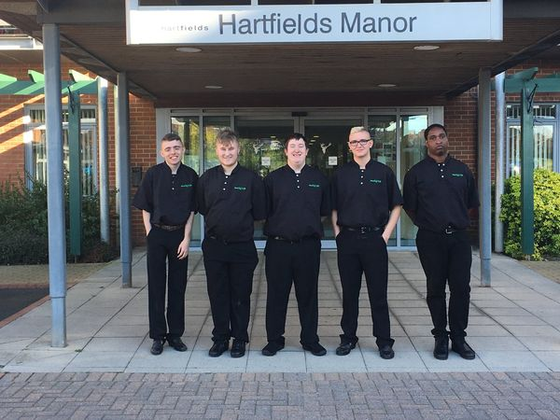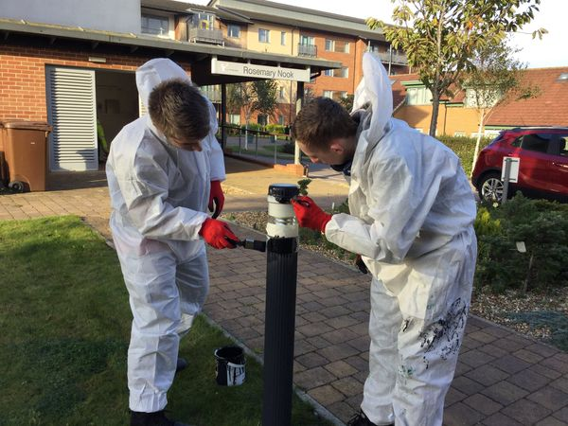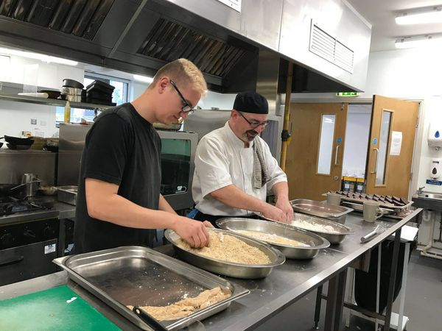
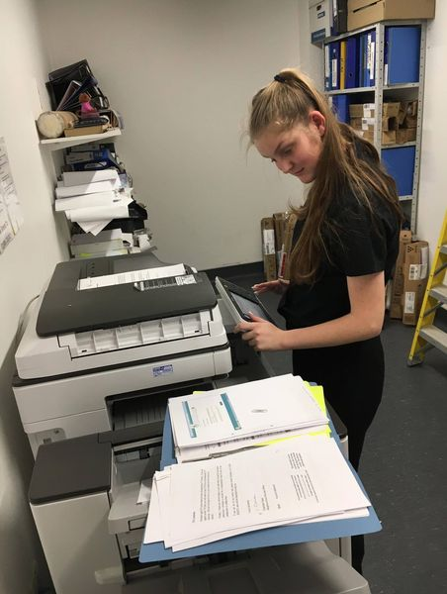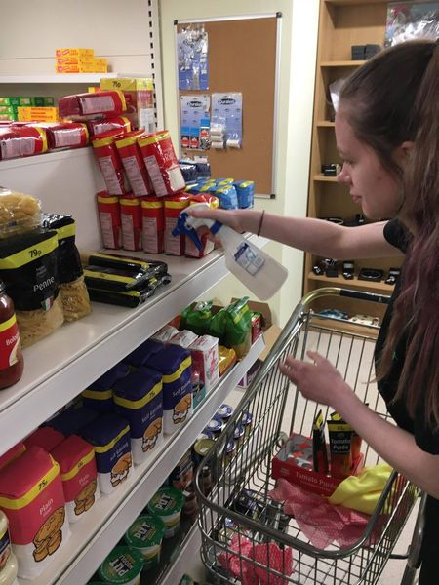
Our Employability students have begun working in partnership with Hartfields Retirement Village which was established and supported by the Joseph Rowntree Foundation our students aged 16-24 accessing the STEPS programme have been gaining valuable work experience in the different departments at Hartfields.
The manager, Kate Thompson, has been a huge support to enabling our young people to develop skills which will hopefully lead to meaningful employment.
#FocusonwhatweCANdo.

