Dutch Garden Centre

Jamie thoroughly enjoyed his work experience in the Dutch Garden Centre today. He loved it and they loved having him.
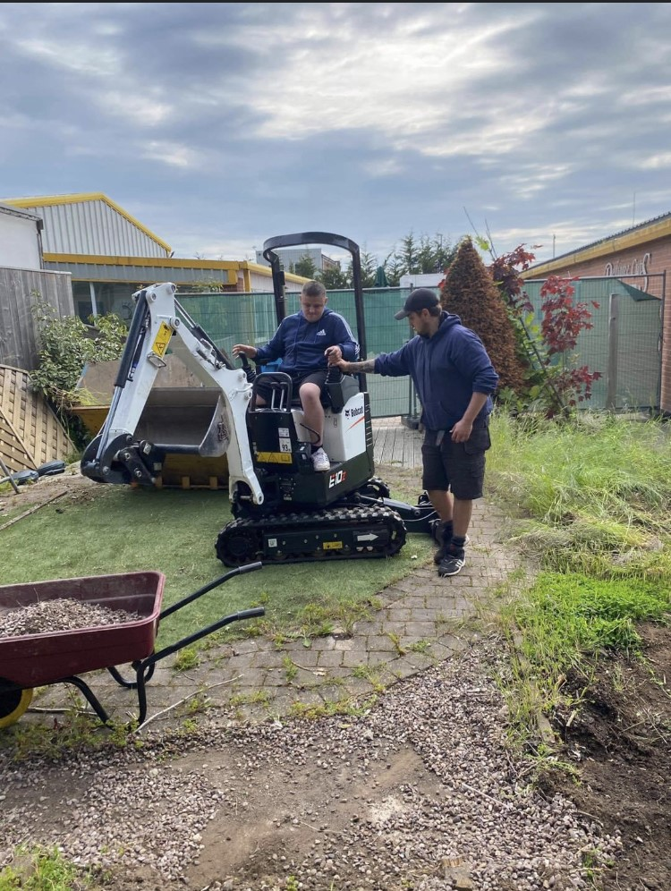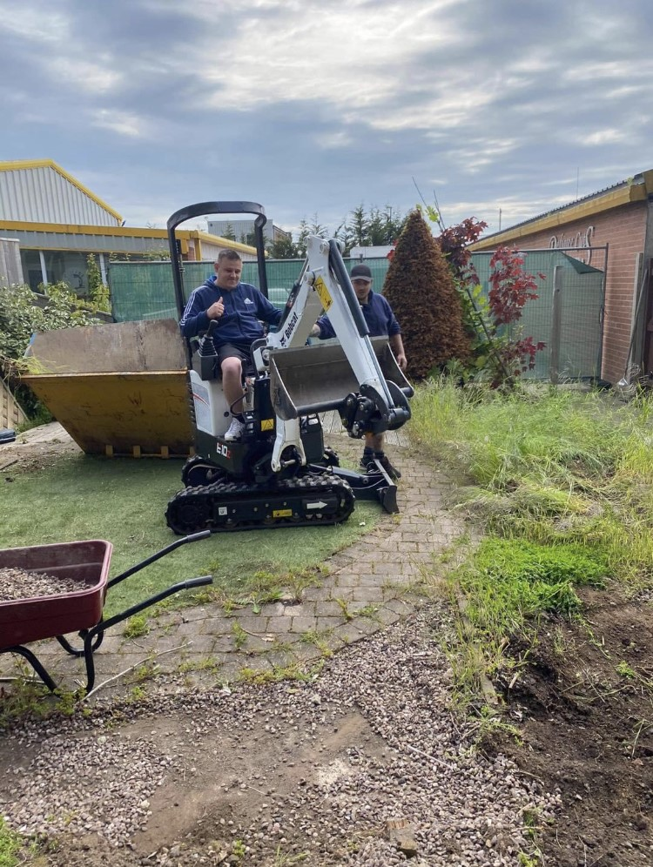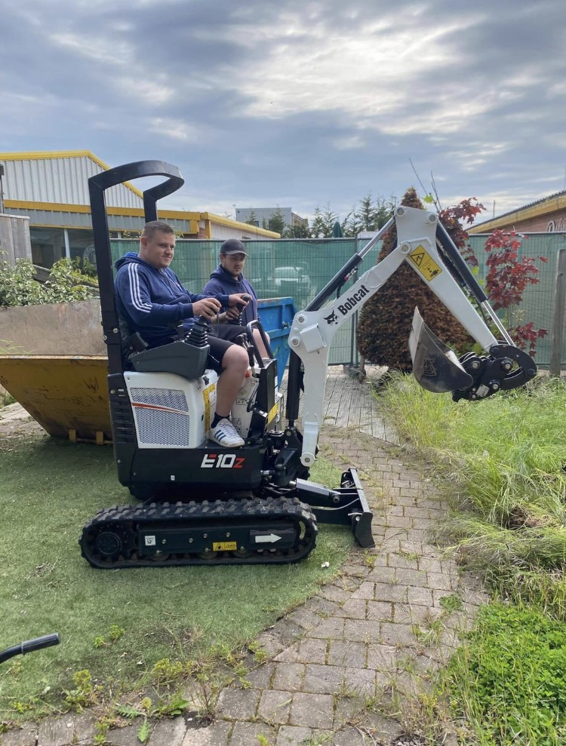
Great job Jamie!

