CF9 Take Over The Bistro
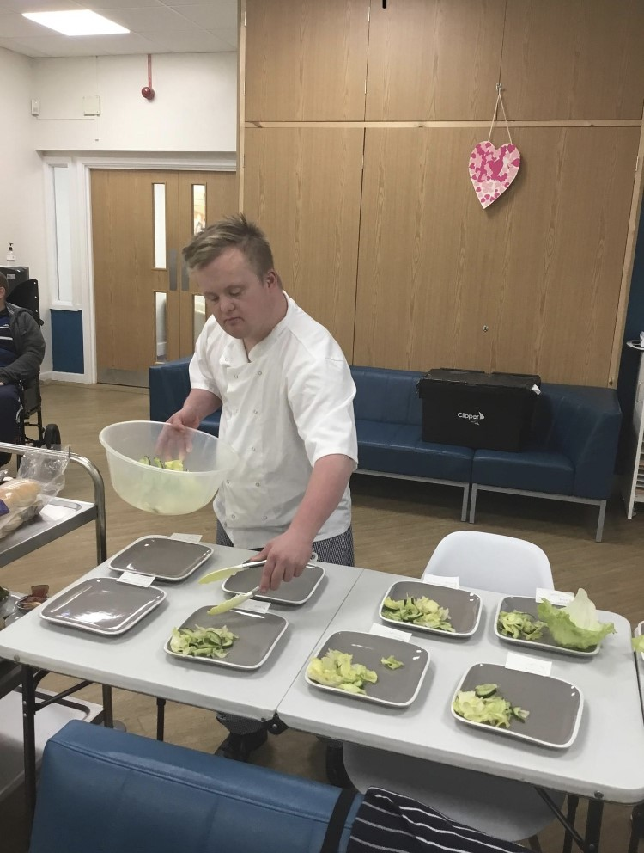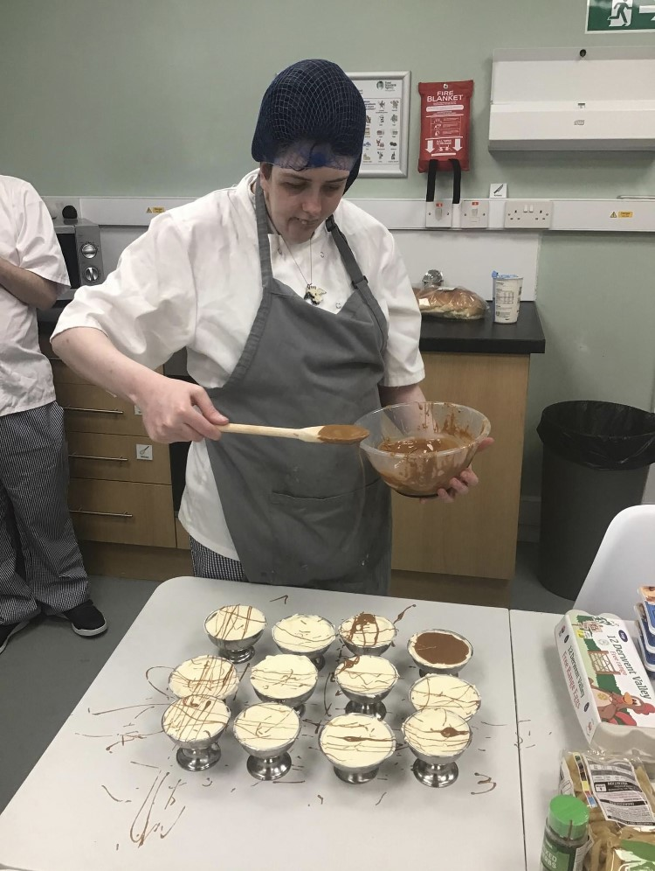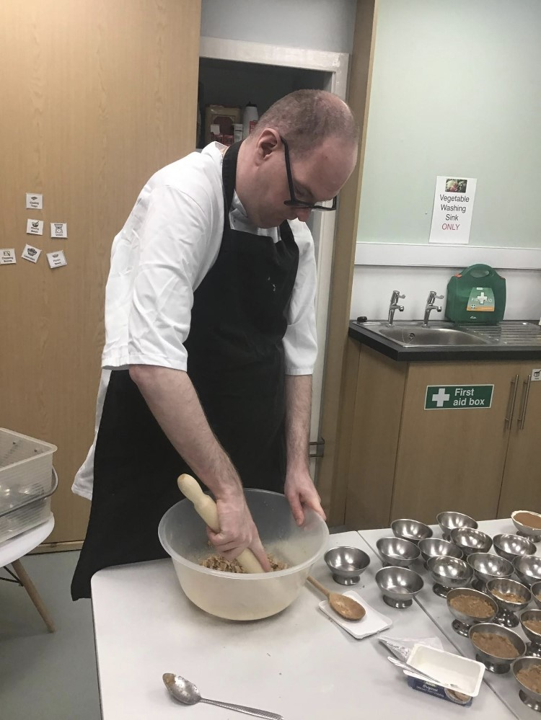
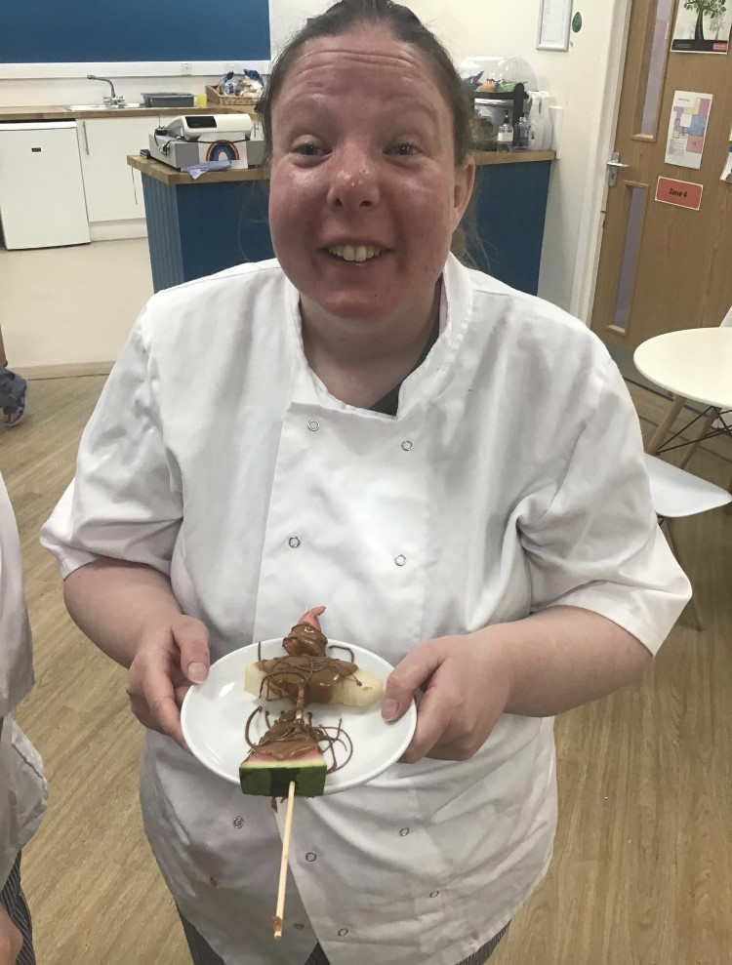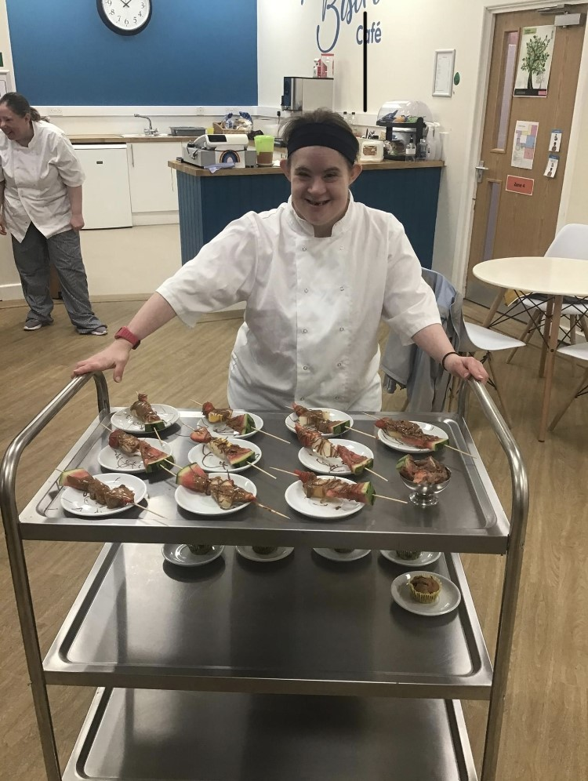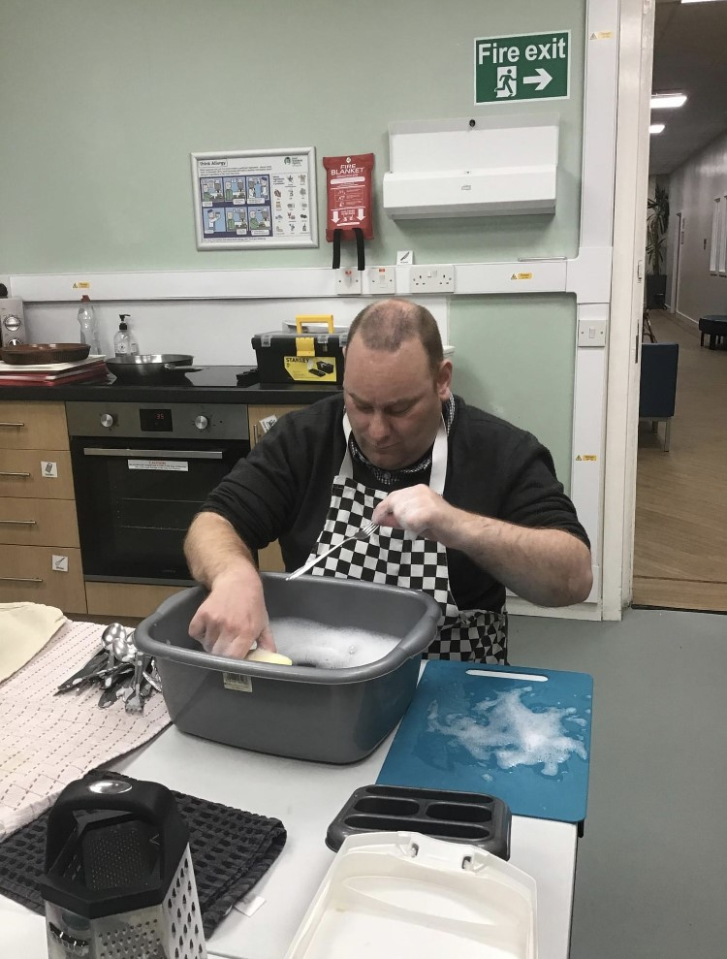
On the last week of term CF9 took part in a work experience week within catering, whilst making money for our Enterprise project. Learners planned and prepared a weekly menu offering freshly baked cakes, scones and homemade snacks for learners’ break times a well as preparing and cooking a range of hot and cold lunches for staff. Learners took ownership of the catering area for the week and prepared some fantastic dishes whilst gaining valuable skills and work experience.
Learners raised £90 for Catcote Futures enterprise fund and worked extremely hard.

