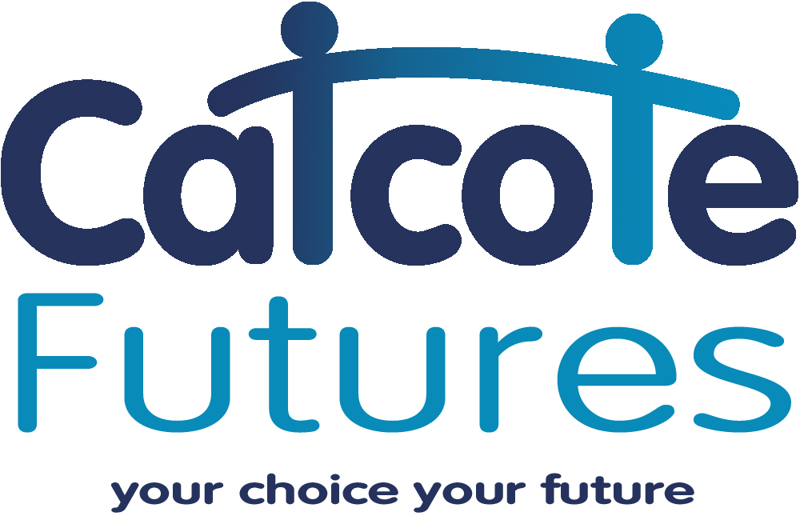

Curriculum Information
Catcote Futures

The Catcote Futures Curriculum Model
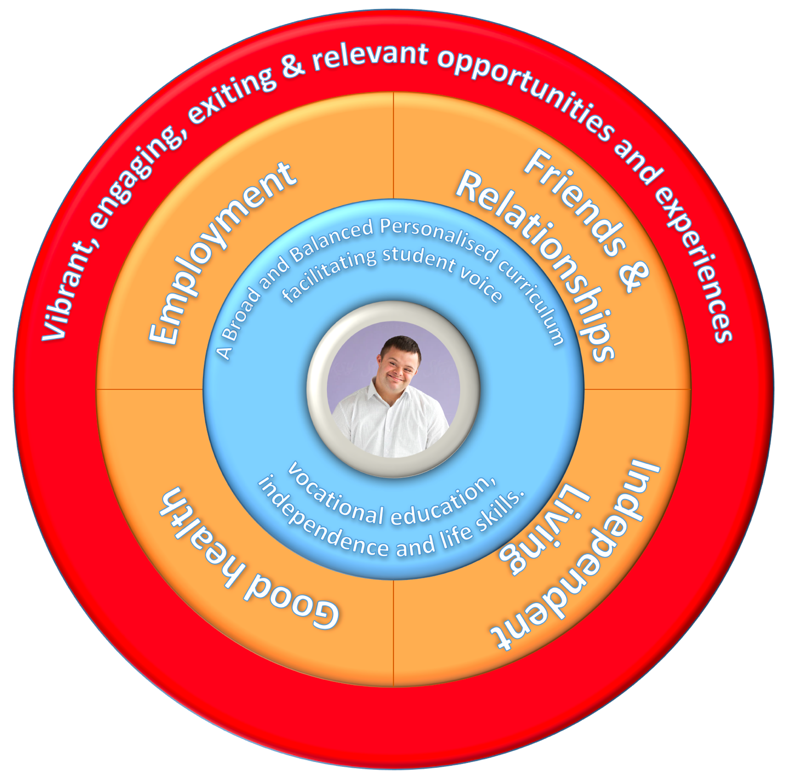

At Catcote Futures we believe that our innovative curriculum makes us truly special. Student voice, student autonomy and student aspirations are at the very heart of everything we do. Where appropriate, our curriculum is fluid and changes termly to offer a wide breadth of options whilst retaining its fundamental core values and building on student progression.
We emphatically believe in lifelong learning at Catcote Futures and, due to the adult nature of our learners, we strive for absolute autonomy in what they choose to learn. We are proud that our students have complete control over their individual study program, which is designed to be relevant, vibrant, broad and balanced whilst underpinning the four key areas of Preparing for Adulthood (Employment & Careers, Friends, Relationships and Community, Independent Living and Good Health.)
Planning and assessment revolves wholly around student and carer agreed outcomes which ensure relevance and progression across our students’ entire career at college. Our creative and highly motivated teaching staff have a vast range of SEND experience and specialist skills to enable them to deliver a range of engaging learning experiences.

The autonomous nature of the curriculum ensures that staff are absolutely passionate about what and how they teach, and students are highly motivated and engaged by the lesson content.

Truly a win-win situation!
The Catcote Futures Curriculum Model

Intent

At Catcote Futures we aim to deliver an ambitious curriculum that is highly motivational and allows our learners to continually build on the skills and knowledge they need to succeed. The curriculum is highly personalised for each student, with their individual study programme tailored to meet the medium and short-term outcomes that have been agreed by our students and their families. All staff teach towards the student’s individual outcomes, ensuring the application of highly personalised key skills in a range of contexts.

Our broad curriculum is ground in the four areas of Preparing for Adulthood to give our students the chance to apply skills and knowledge in a range of exciting, relevant, age-appropriate learning opportunities.

All of our learning experiences are geared towards enhancing independence skills, student wellbeing, making a positive impact in the community and the world of work. Continual assessment of student outcomes in these lessons helps to facilitate maximum progress.

Implementation

Lessons are taught by highly effective specialist staff with a wide range of pedagogical knowledge and SEND experience. We employ a practical, vocational approach at Catcote Futures with an aim to see as many students as possible accessing the world of work, independent living and contributing positively to society.

Where appropriate, our curriculum choice is completely autonomous, with students choosing what lessons they will access each term based on interests, aspirations and need. Each students’ bespoke study programme is then adapted to meet their identified outcomes.

Effective, ongoing assessment is used to ensure that students are making progress from their starting points in their personal outcomes. Each student has a personalised outcomes book, which is continually completed by staff, so the student is keenly aware of their targets, what they are working towards and how well they are progressing.

Impact

Our broad and very rich curriculum allows us to maximise targeted, sustained progression to all students, increasing their application of skills and knowledge. Effective accredited and non-accredited lessons, taught by staff who are motivated to teach, to students who are engaged and keen to learn, has proven to be extremely successful.

The co-authored, autonomous nature of the curriculum gives our learners a real say in their educational journey and the continued, explicit focus on personal outcomes ensures that students are aware of what they need to achieve, and their next steps to reaching their goals.

With continually motivated learners following a stimulating, broad, purposeful and imaginative curriculum, we are confident that our learners will be happy and successful wherever their next destinations lie.
The Catcote Futures Curriculum Model
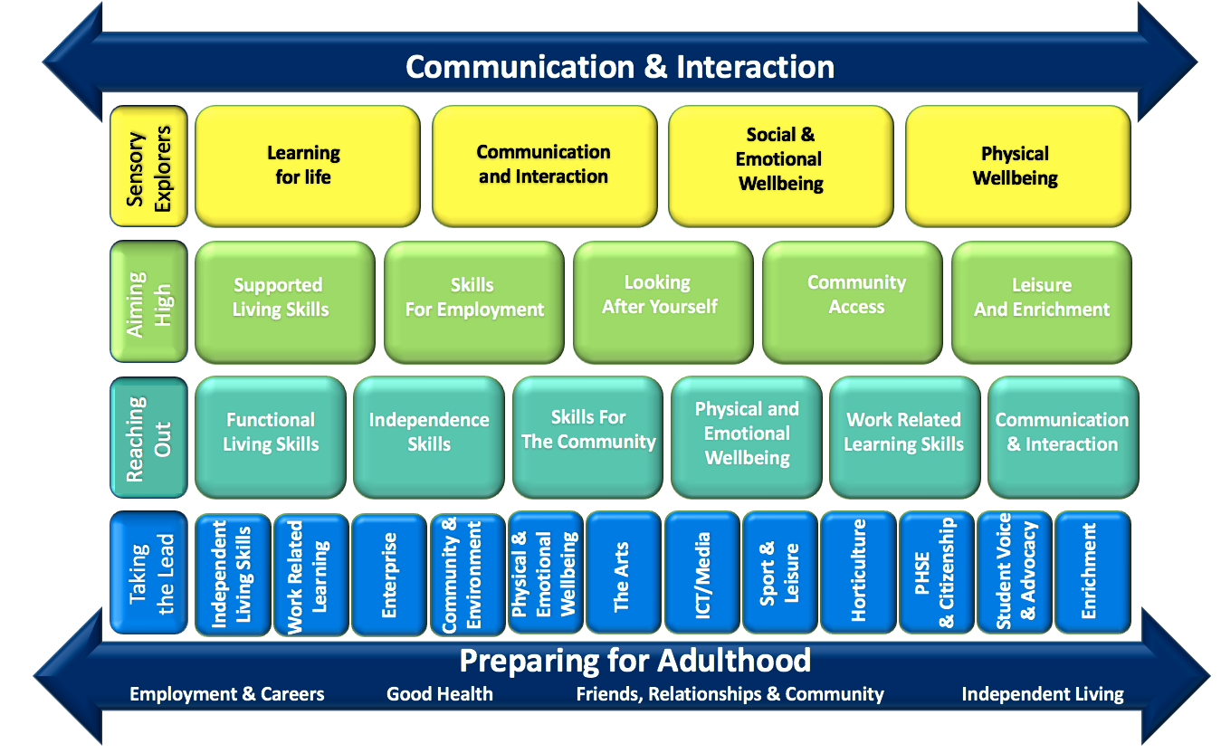

Our vibrant and diverse community of Catcote Futures learners mainly follow one of four Pathways. However, they are actively encouraged to experience any relevant activities from all pathways across college. Student voice is paramount at Catcote Futures so, where possible, students choose all modules of their own individual study programme.

Our Pathways are as follows:

Sensory Explorers: A specialist sensory and communication-based Pathway designed to maximise experiences and opportunities for our students with profound and multiple learning difficulties.
Aiming High: A pathway for our students identified as having a wide variety of complex needs. This group are taught using a range of specialist approaches in a base class and access other areas of the curriculum as appropriate.
Reaching Out: A pathway designed to maximise opportunities for students with ASD. This group are taught using a range of specialist approaches in two base classes, accessing other areas of the curriculum as appropriate.
Taking the Lead: Our programme for learners identified as having severe learning difficulties. Here, students choose options termly, based on their needs and aspirations.

Communication and Preparing For Adulthood are embedded across all learning experiences.
The Sensory Explorers
Pathway

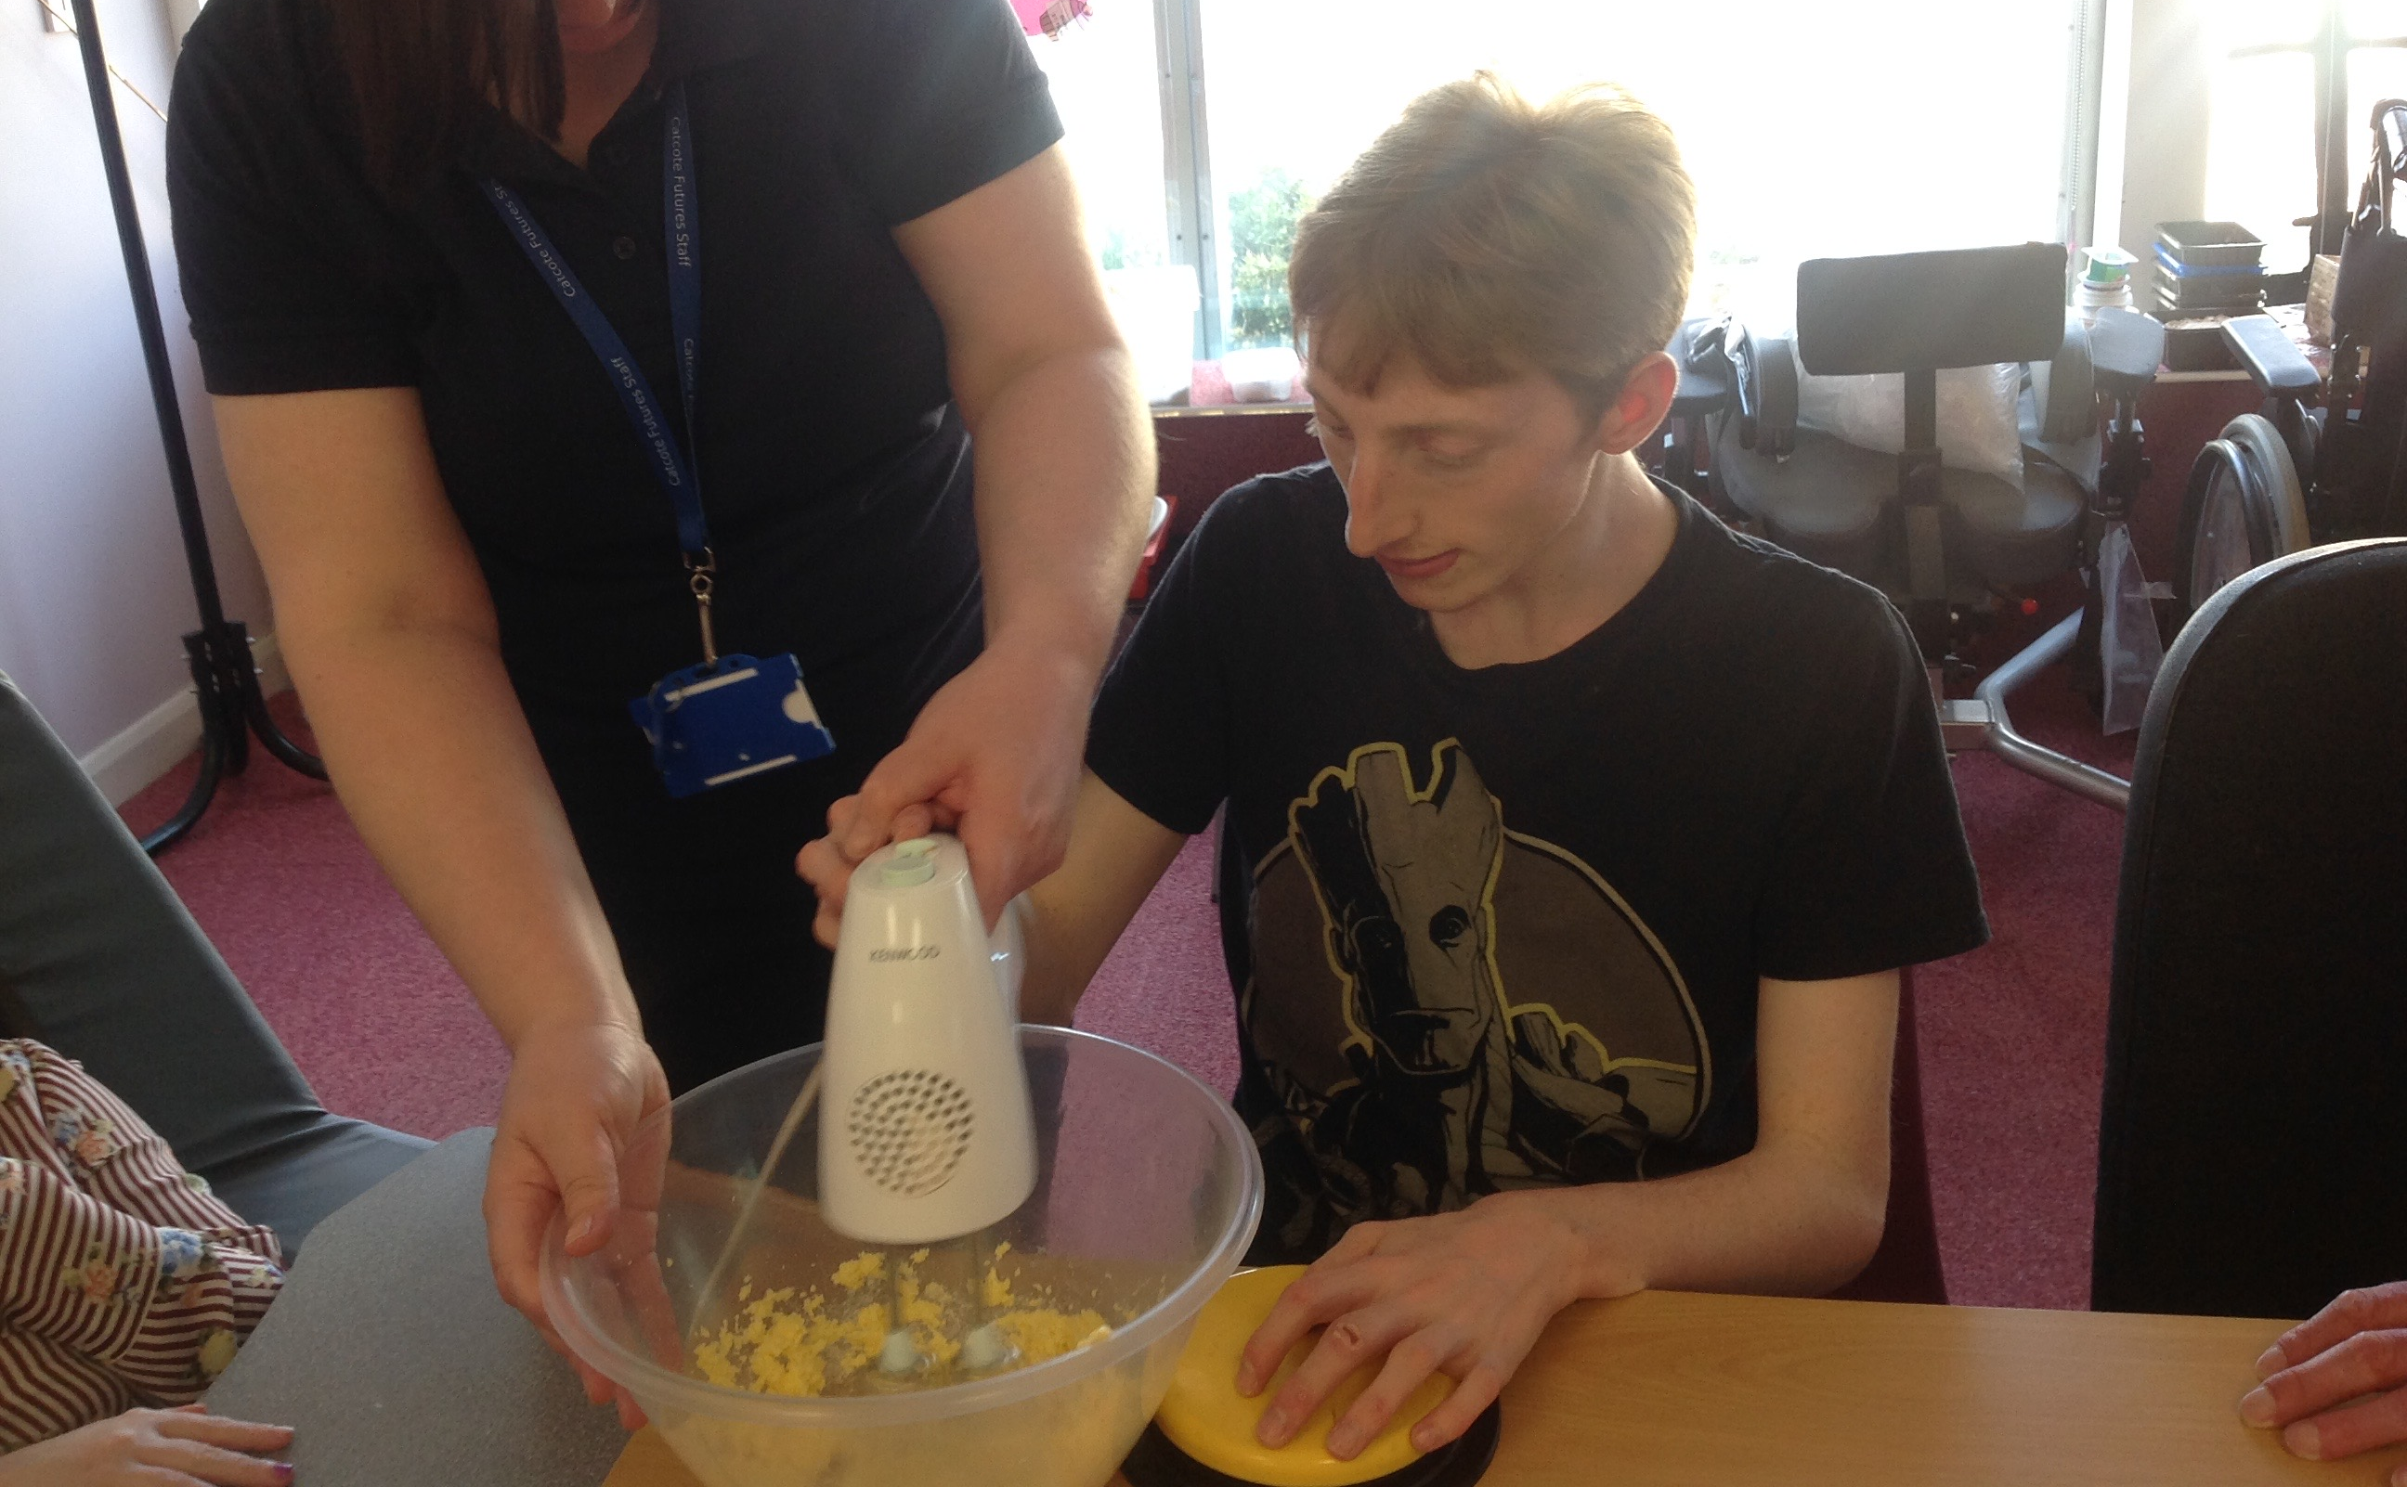

Learning for Life - At Catcote Futures, our Sensory Explorers access a full, broad and balanced curriculum designed to improve their life skills, independence skills and sensory experiences. Each day begins with a stimulating Senseology workout, where students practice a range of personalised targets. Their busy week includes access to a range of stimulating community visits and meaningful work-related learning activities such as enterprise skills, horticulture and a range of sensory activities in our salon. Our sensory explorers enjoy a range of bespoke sensory activities designed to promote independence skills and communication such as art, cookery, ICT and outdoor education.
Communication and Interaction - At Catcote Futures communication is key. Our Sensory Explorers have access to a wide range of high and low tech augmentative and alternative communication strategies and equipment. This helps maximise their communication, social and independence skills across everything they do. We have a range of switches and specially adapted equipment to ensure that students continue to develop their cause and effect and control skills. Students also access highly stimulating, age-appropriate sensory stories several times per week to promote and develop pre-verbal communication, engagement and exploration in an extremely enjoyable way.

The Sensory Explorers
Pathway
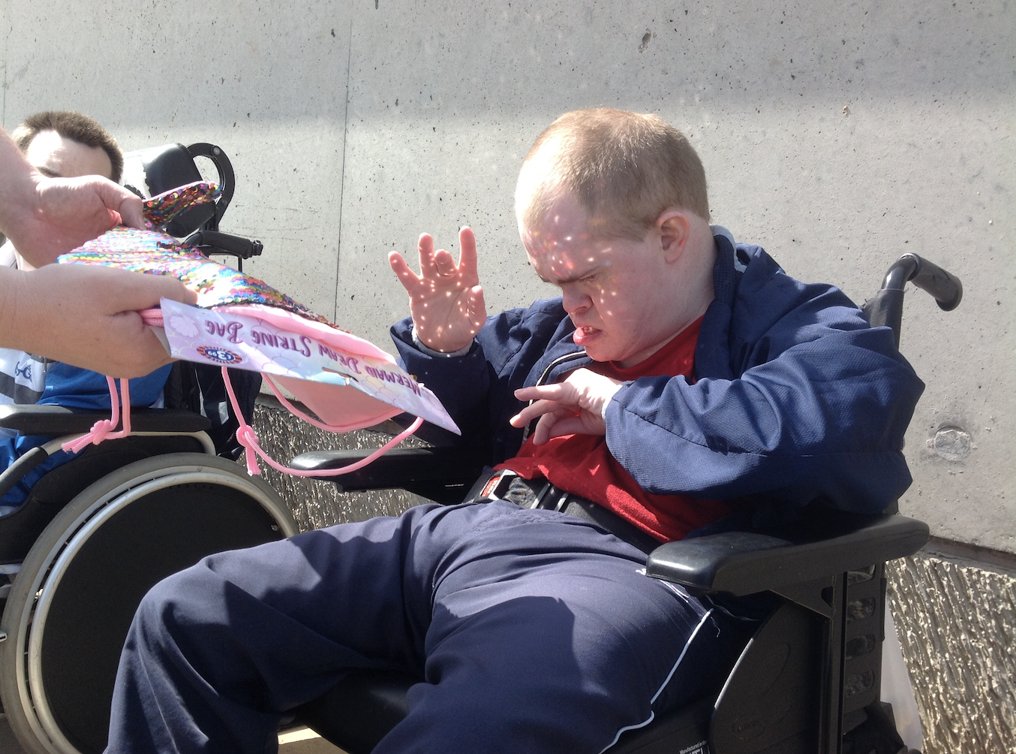

Social and Emotional Wellbeing - At Catcote Futures the social and emotional well-being of our students is paramount. Our Sensory Explorers enjoy a range of stimulating activities and therapies in a relaxed, yet invigorating environment. As part of their week, students enjoy guided massage and other therapy sessions, including music therapy, tac pac or spending time in our bespoke salon.
Physical Wellbeing – Our Sensory Explorers have access to a range of activities designed to maximise their physical wellbeing. Students follow personalised physiotherapy and occupational therapy programs and have access to our on-site Jacuzzi and sensory space. Students use assistive technology to create a range of healthy snacks which are then eaten as part of an integrated feeding programme. There are several opportunities for massage throughout the week as well as more vigorous activities such as dance and exercise.

The Aiming High
Pathway

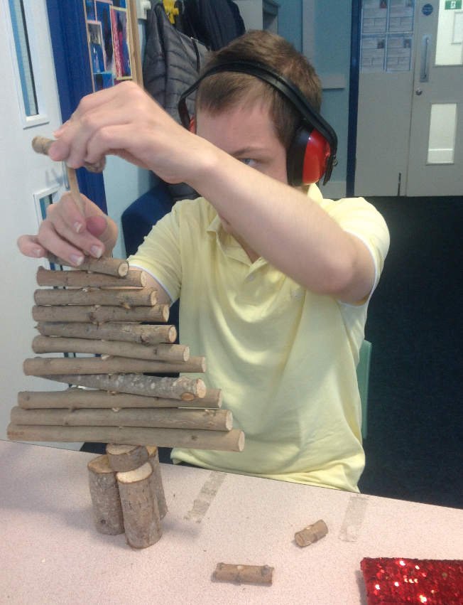
Supported Living Skills – In the Aiming High pathway group, we provide daily opportunities for the students to take part in activities which develop key skills that they will need for the future such as various forms of expressive (speaking) and receptive (listening) communication skills, interaction skills, laundry, cookery, cleaning, using household technology, getting dressed and opportunities for independence.
Skills for Employment – In order to develop the students’ employability skills, they access personalised enterprise and work experience tasks, such as setting the dining room, reception duties, woodwork and horticulture. Enterprise projects and tasks are also adapted to incorporate the students’ individual skills. Our students regularly make products to sell at enterprise fayres.

Looking After Yourself – Daily opportunities are provided to encourage the students to look after themselves. Staff consistently provide opportunities for the students to demonstrate their independence skills as often as possible. The students access specific activities and experiences such as PSHE, hair care, relaxation and a range of massages such as, Indian head, hand, feet. These experiences are also used to help the students to self-regulate and to assist them to access their learning.

The Aiming High
Pathway

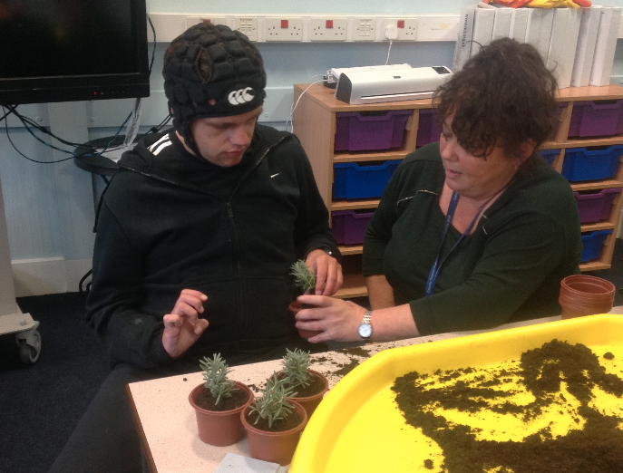

Community Access – Accessing the community is extremely important part of our pathway in the Aiming High group. It enables the students to practise and apply a wide variety of skills in the real world. They are also strongly contribute towards developing the student’s social skills, self-confidence, self-esteem and independence and functional application skills.
Leisure and Enrichment – The students in the Aiming High group enjoy taking part in different leisure and enrichment activities as part of their personalised timetable. Experiences such as pottery, Zumba, Jacuzzi, community visits, relaxation and massage are all opportunities that the students have chosen to take part in as part of their personal programme. Opportunities such as these are also used to provide the students to work alongside peers and staff from across the college.

The Reaching Out
Pathway

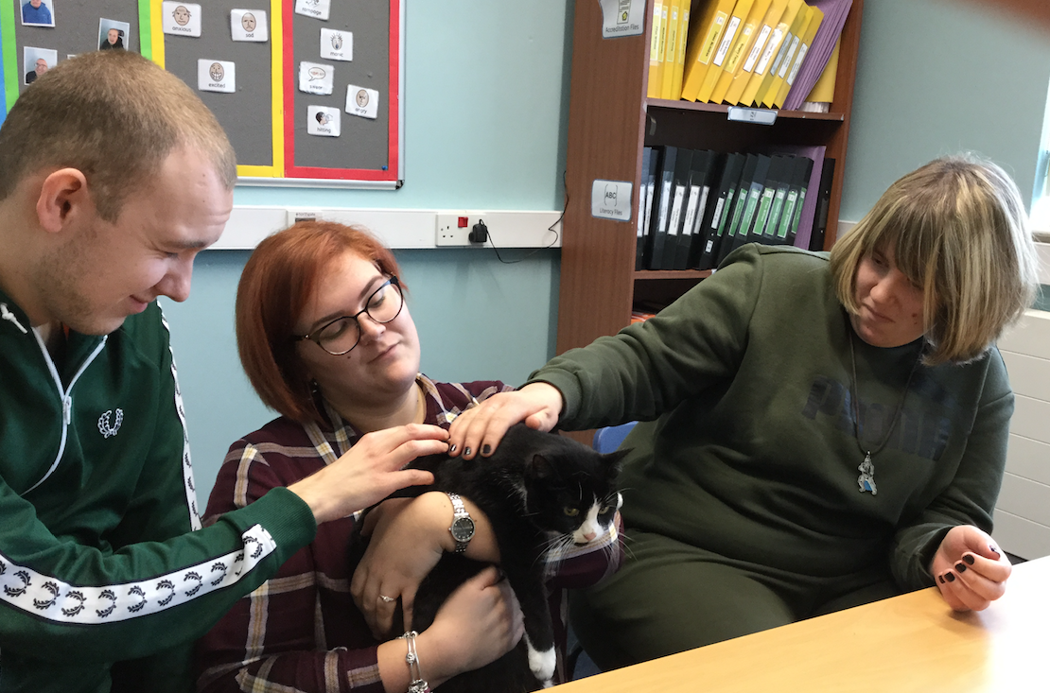

Functional Living Skills – We focus on functional skills through structured functional literacy and numeracy sessions. Pupils are supported to gain understanding within key topics such as money and time, and opportunities are made for students to practice these skills in a variety of contexts. They are also given the support necessary to transfer the skills to the wider community. Personal effective strategies and support are used to enable students to fully engage in learning.
Independence Skills – Students following our Reaching Out programme are encouraged to be as independent as possible which is reflected across their study programme. Students complete a range of activities linked to looking after their own home as well as increasing vocational and self-help skills.

Skills for the Community – Our students have several opportunities to visit the local community every week, accessing a range of local shops, amenities, cafes, restaurants, work placements and much, much more.
Physical and Emotional Wellbeing – As part of our autism specialised curriculum, students follow a highly structured program with predictable routines. Visual timetables, and where appropriate, individual visual supports such as now and next cards used to promote understanding. Having familiar and structured routines are key factors that enable our students to access vocational areas of college and the wider community. Students are presented with food facts and are supported to make healthy eating choices, they regular exercise to help them regulate and have access to a number of quiet spaces when required.
The Reaching Out
Pathway

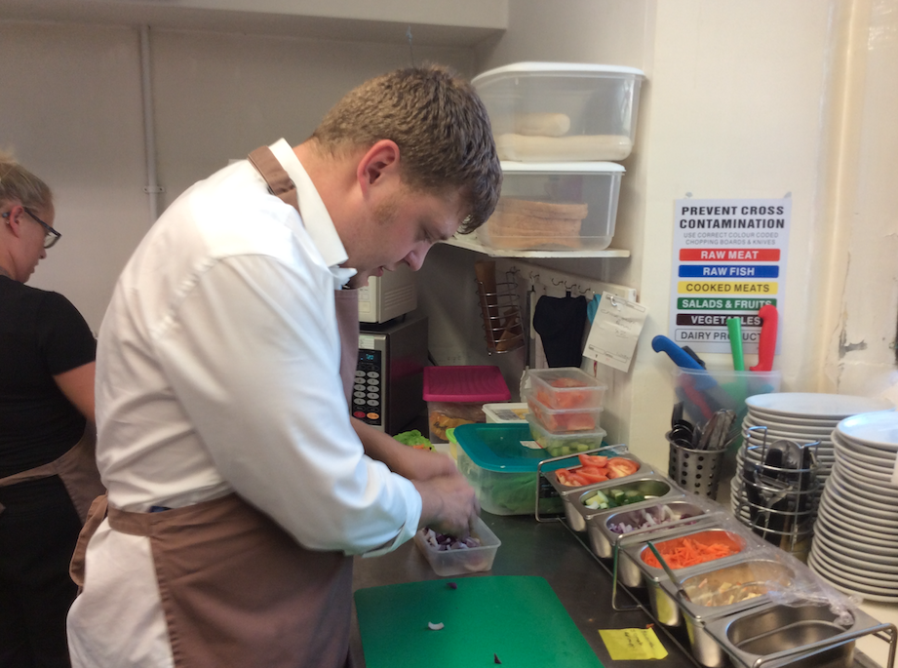

Personal and Social Development - PSD sessions concentrate on developing new skills to Enable students to gain control over their own emotional regulation, this has had a hugely positive impact on behaviours.
Work-related Learning – Students attend work related sessions within the college and also in the wider community. Sessions are tailored to meet the needs of the individual learner with autism using familiar routines, timetables and skills stuff in please to facilitate the sessions.
Communication and Interaction – Students are given many and varied opportunities to develop and practice social interaction skills and to development communication skills. Small group and one-to-one teaching of new skills is provided at each stage and in all areas of the curriculum. Video modelling, real life scenarios and appropriate role modelling are included in focused lessons for our students.

The Taking the Lead
Pathway

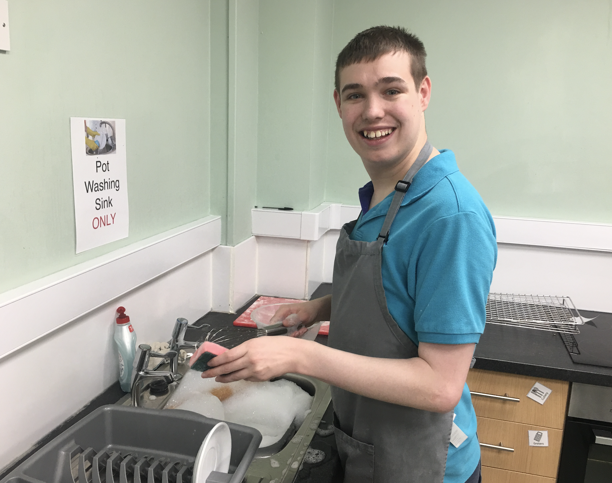

Independent living skills - In the Taking the Lead pathway we offer a range of different lessons centred around independent living skills. Through use of the life skills caravan at Crimdon Dean, students experience real life tasks associated with living independently, such as preparing meals, cleaning, cooking and budgeting. In addition to healthy eating in cookery lessons, the students develop their key skills to prepare a range of meals, understanding the needs of a balanced diet and eating appropriately around others. Students also use our flat to practise the skills needed to look after their own home.
Work Related Learning - Our students are encouraged to access the world of work and we strive to support them every step of the way towards gainful employment. Within the centre, we have excellent facilities which students can experience a real working environment; these include our bistro vestry and even our own shop positioned in Hartlepool town centre. If students choose to develop further, we have many links to local employers which has led to full-time employment for several of our students.

Enterprise - For many years enterprise has been the backbone of teaching and learning at Catcote. Students learn valuable work, business, team building and life skills through practical learning activities around enterprise. This includes working with educational establishments across the world and producing a range of products for sale at local fairs and in our Catcote Metro shop.

The Taking the Lead
Pathway
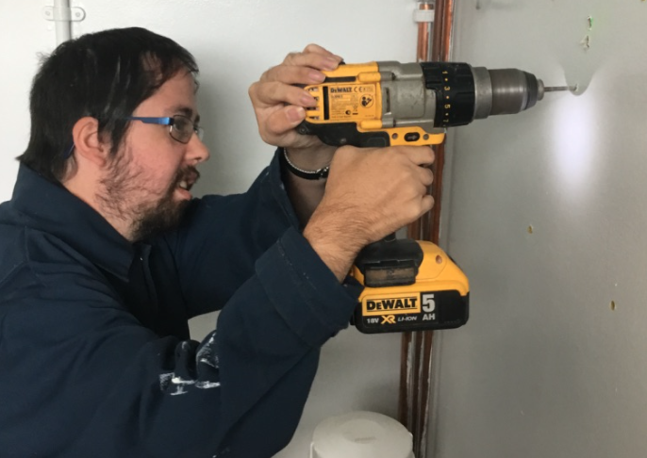

Community & Environment - We are proud of the facilities in Hartlepool and encourage our students to experience as many of them as they can. From taking photographs of local landmarks and beauty spots for our annual calendar, exploring birds and seals at Saltholme RSPB to visiting a range of shops, cafés and restaurants, we are committed to ensuring that our students are valuable and well-respected members of our local community.

Physical and Emotional Well-being - Catcote futures boasts a professional beauty salon with adjoining Jacuzzi, which is overseen by a full-time hair and beauty teacher. Students are encouraged to give and receive a variety of treatments and therapeutic experiences to maximise their physical and emotional health. We have two trained Thrive practitioners who work with students with social and emotional health difficulties in a sensitive and empathetic manner.
The Arts – At Catcote Futures we enjoy a range of art and craft-based experiences including pottery in our fully functional pottery room. We have a large ‘Creative Crafts’ space which gives students the opportunity to use various materials to create individual pieces of art and sculpture. Students can also work with a range of resistant materials in our fully functional woodwork shop. Students who enjoy performing arts can choose a variety of modules including exploring performance, exploring dance and much, much more.

The Taking the Lead
Pathway

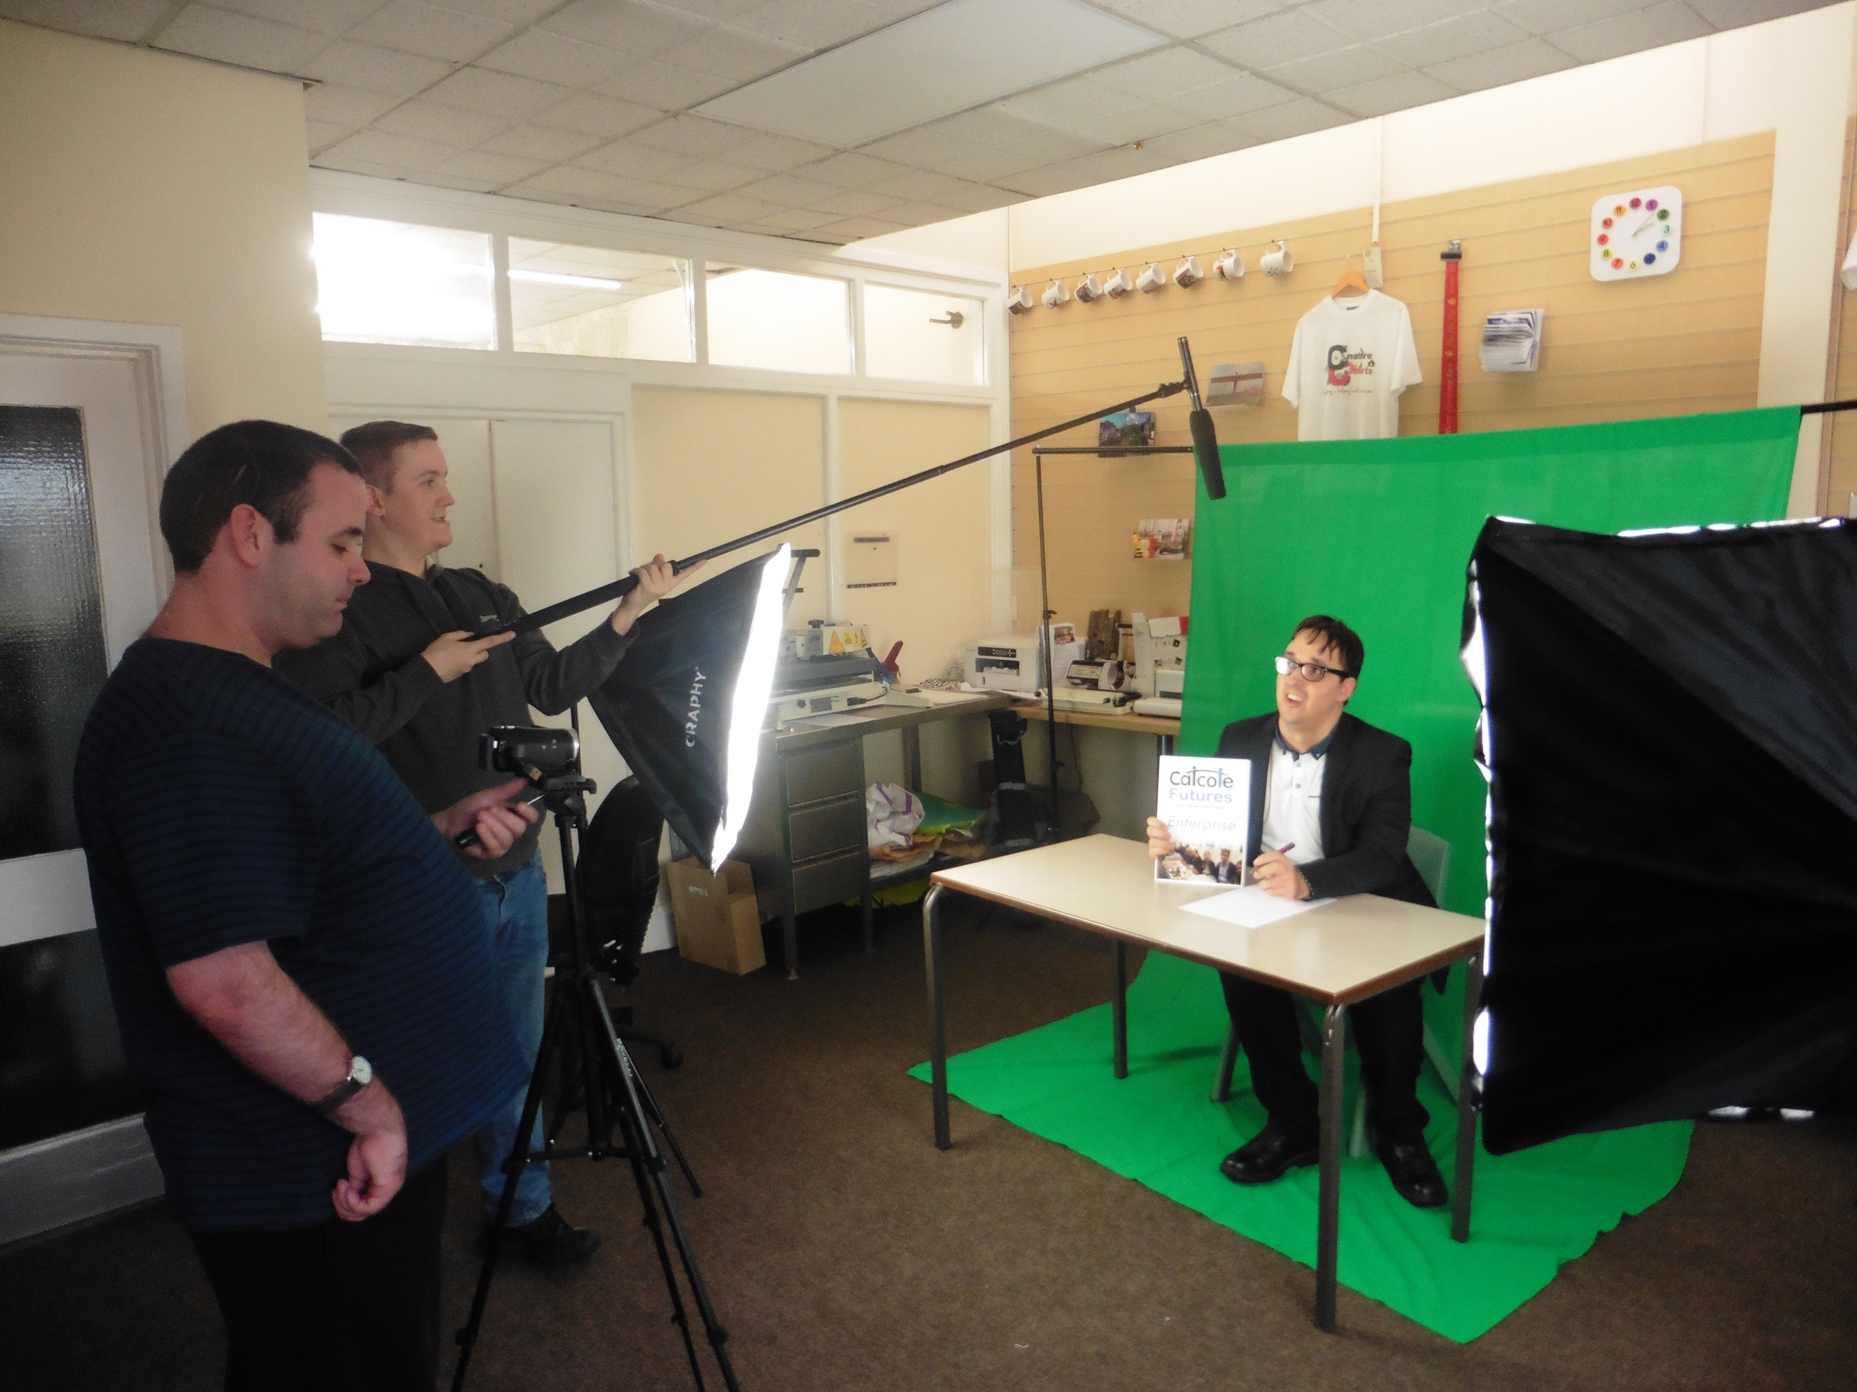

ICT/media - We have a specialist media teacher at Catcote as well as our own film production company called Catcote Productions. We make a range of entertaining and educational films as well as ‘Catcote Cooks’, our weekly cookery show. We have state of the art digital equipment and our own Green Screen to ensure that our projects are only limited by our imagination! In our reprographics room we have a suite of Apple Mac computers and many portable devices such as digital cameras and iPads to ensure we are at the cutting edge of learning.

Sport and Leisure - Physical well-being is extremely important and at Catcote Futures we have a specialist sports teacher who provides a range of appropriate exercise-based experiences for all learners. From wheelchair dancing to rugby, orienteering to cricket and Zumba, there are a range of sporting activities for everyone!

Horticulture - Horticulture is a very well-established area at Catcote Futures. Students learn how to work safely and use tools correctly to grow a wide variety of fruits, vegetables, plants and flowers in well-equipped facilities. These include a greenhouse, poly tunnel and garden buildings. Students also enjoy working and learning in the extensive grounds and our sensory garden.
The Taking the Lead
Pathway

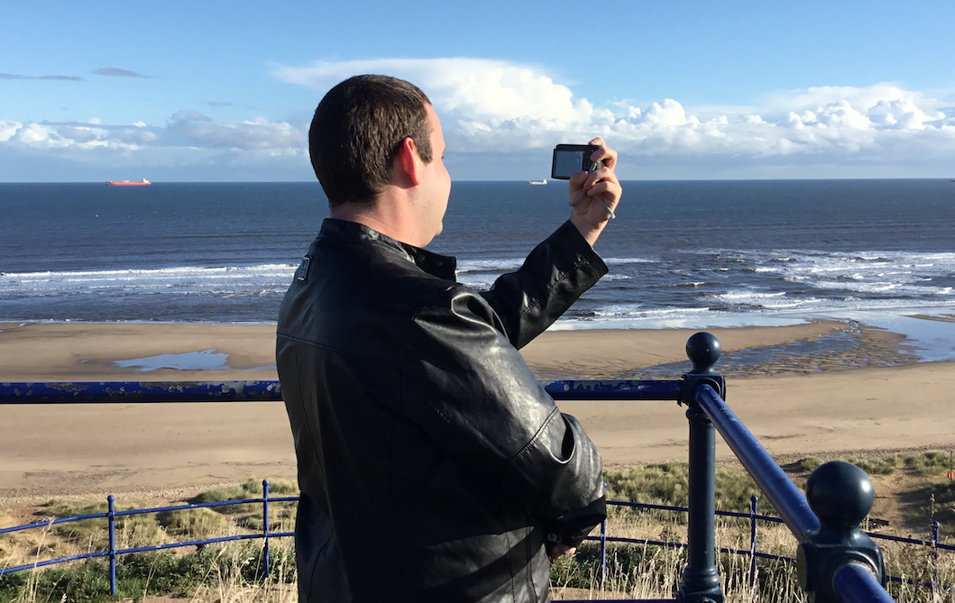

PHSE & Citizenship - Through focused pastoral sessions and a range of targeted lessons, students learn the skills to look after themselves, stay healthy, make sense of the world around them and the expectations of society at large. This includes respecting the role of law, understanding and welcoming diversity and making social and moral choices.
Student Voice & Advocacy - Student voice is at the heart of everything we do, with students fully in control of their learning experiences and day-to-day happenings in the curriculum. We have a thriving student council at Catcote Futures who work with our senior leadership team to make a real impact in future developments at the college.
Enrichment - There are many enrichment opportunities at Catcote, we offer a focused enrichment afternoon where students to choose from a menu of appropriate and exciting choices such as cake decorating, singing and signing choir, filmmaking, outdoor pursuits and more.
Preparing for Adulthood

The Preparing for Adulthood model is fully embedded in the Catcote Futures curriculum. This nationally recognised programme for young people and adults with learning difficulties consists of four key areas:

Employment & Careers: providing clear, evidence-based employment pathways with opportunities for volunteering, supported internships, traineeships and apprenticeships and good careers advice and guidance to help young people with their decision-making.
Friends, Relationships and Community: Giving our learners the skills to spend time with their peers outside of school and college. They are supported to develop and maintain friendships and relationships. They can access their community and feel safe and confident.
Independent Living: providing a focus on skills required to live independently or semi-independently.
Good Health: Our learners are supported to manage their own mental and physical wellbeing.

Our curriculum offer is audited termly to ensure that full coverage of the four areas of Preparing for Adulthood is offered. Following this, each students’ individual study program is audited by pastoral tutors to ensure there is complete coverage of all areas of Preparing for Adulthood. This helps ensure a broad, varied and challenging curriculum and that has these important principles at its heart.

Communication & Interaction
Communication and interaction run through absolutely everything we do at Catcote Futures! We firmly believe that communication forms the basis of all behaviour, and effective communication and interaction are fundamental human rights.

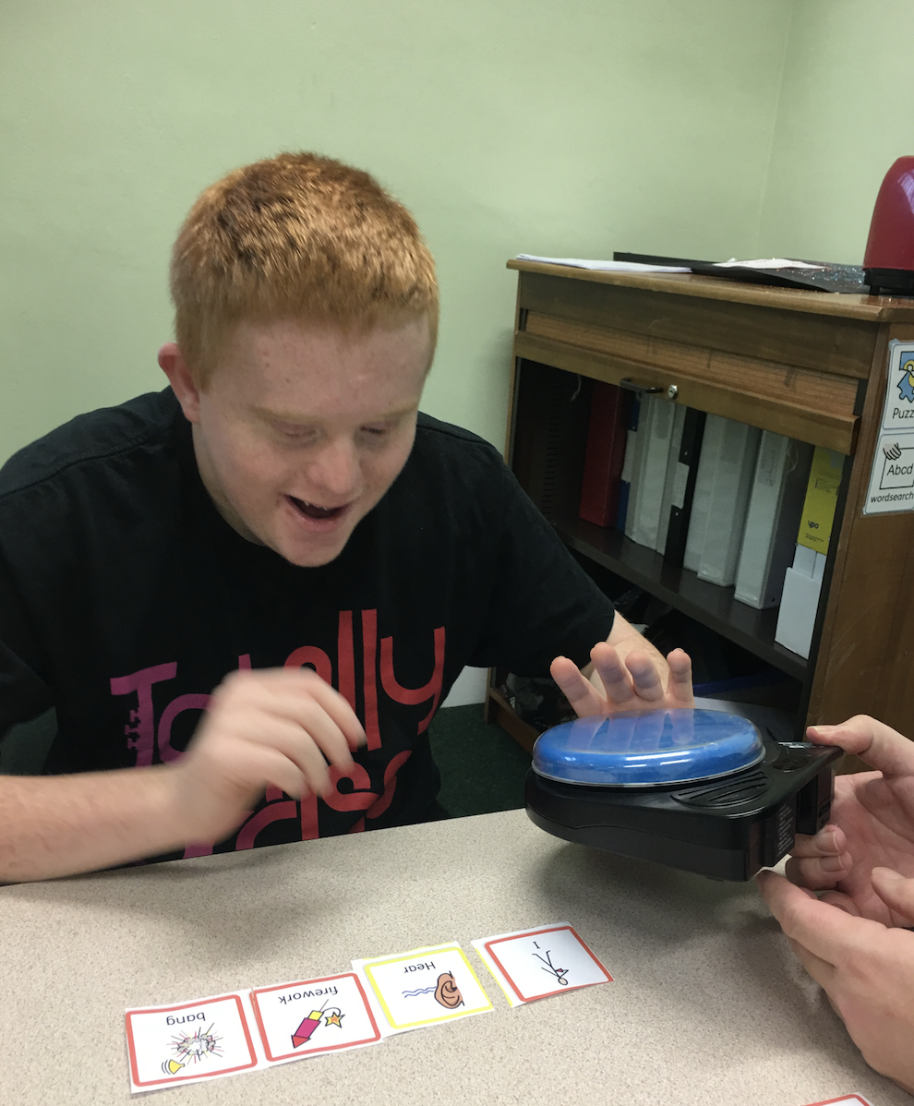
Catcote Futures is a total communication environment, this means that consistent approaches to communication and interaction are adopted by all staff, and harmonious and uniform visual supports, objects of reference and other communication strategies are embedded across college. This enables our students to be as independent as
possible as well as fully understand what is happening
now and next. Staff employ a range of specialist
approaches to maximise communication and
interaction, including a range of augmentative
communication strategies such as sign, symbols, the
PECS approach and a range of high and low tech
communication aids.
Each student has a communication outcome, which is
designed to improve their expressive and receptive
communication skills.

We are passionate about student voice at Catcote
Futures and firmly believe it is our moral duty to
ensure that our students can make their thoughts,
wishes and needs as explicit as possible. We have a
strong and active student council at Catcote Futures,
whose job it is to meet weekly with the senior
leadership team to represent their peers and steer the
direction of the college.
Assessment and Progress

In order to assess the progress of our young adults against their personal targets, we use the MAPP continuum. This allows us to closely monitor progress of skills that we would like our students to develop in order to maximise their potential. All of our students have a bespoke outcomes book which they take every lesson. Outcomes are decided, with the help of the teacher, student, their families and health and social care professionals during EHCP meetings or Annual Review for our Life Long Learners. Students are made explicitly aware of their targets daily, agreeing which ones they will address during their sessions for that day. At the end of each session, students and class staff give feedback on the targets stating how they have met them and what comes next.
Pastoral teachers have weekly meetings with learners to discuss and celebrate targets and achievements. If any interventions are required, staff and students agree them here. Teaching staff share feedback termly to senior leaders in one-to-one meetings, as well as to all staff during dedicated assessment and progress meetings.
This system ensures that all staff are aware of all students targets and progress, enabling them to plan effectively for each individual they teach. Students are also more aware of their targets (which are given in a symbolised format for those who need it, giving further autonomy and control of their individual study program and a real say in their outcomes.
Summative assessment is carried out through termly outcome reviews and also through termly reviews of accredited outcomes. At Catcote Futures our learners follow either NOCN or OCR accredited courses, with modules changing each term. Moderation is carried out internally each term and externally annually.

Challenge

At Catcote Futures we see our curriculum as an excellent vehicle for delivering individual student outcomes, whilst stretching and challenging our learners. The warm and supportive spirit of the college allows our students to take risks, embrace failures and build resilience.

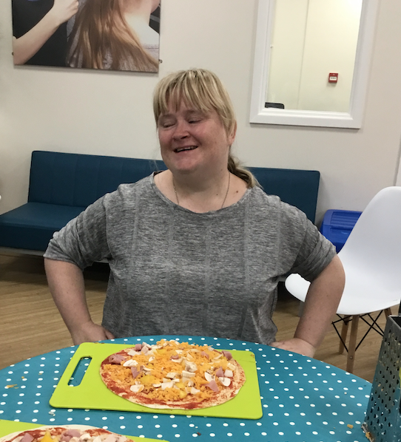
Through termly curriculum planning meetings with both staff and students, teaching staff ensure that our curriculum offer provides a menu of innovative, yet challenging choices for our students that build on previous skill acquisition.

Teachers plan each term’s work based on agreed learning intentions and/or accredited outcomes, and then each session based on individual student outcomes.
Using this system we can ensure that student progress is continual and outcomes continue to be met whist embracing innovation and challenge.

Again, as subject choice is autonomous and based on student interest, students are much more likely to take risks, embrace challenge and persevere in the face of failure.

Quality Assurance

Teaching staff meet termly to discuss and agree forthcoming lessons, which have been co-authored by our students. The curriculum manager then creates the timetable based on staff and student interests. A termly audit is carried out to ensure that the curriculum choices offered to students sufficiently cover the four areas of the Preparing for Adulthood programme.

Final curriculum choices are then given to students and individual study programmes formulated. Once the student has chosen their study program for the term, a further audit takes place to ensure a broad and balanced curriculum is enjoyed by students and there is sufficient coverage of all areas of Preparing for Adulthood.
At the end of each term students are asked to complete an evaluation of the modules they have studied. This ensure that student voice is heard and helps staff ensure that our curriculum remains relevant, fresh, challenging and exciting.
Catcote Futures it’s part of Natspec, an association for organisations which offer specialist further education and training for students with learning difficulties and/or disabilities. This enables us to work closely with organisations to help us share ideas, keep abreast of current developments in curriculum design an adult education as well as quality assure everything we do.

Student Voice

Our adult learners at Catcote Futures are treated with the utmost dignity and respect. We are passionate about student voice and firmly believe that our students are more than capable of shaping not only their own educational program, but the direction and decision-making within the college as a whole.
Students are responsible for choosing the content of their own study program and our student council meet with the senior leadership every week. During these meetings, elected students decide future events and direction of the college as well as putting forward curriculum ideas and discussing any college related issues that students may have brought to them.
Students have weekly pastoral sessions where they can discuss their progress and any issues with their tutor.

Catcote Futures Curriculum
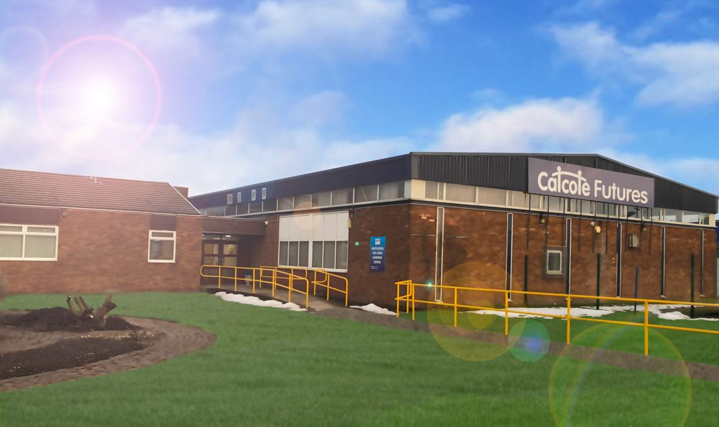

Catcote Futures Learning and Skills Centre is a unique college offering a stimulating, personalised and fulfilling curriculum which is dynamic in its development. We firmly believe that our students deserve as many opportunities and experiences as we can offer to support them on their journey into adulthood. We are committed to providing realistic opportunities through our exceptional vocational skills centre and with an extensive range of local employers in a friendly and rewarding atmosphere.
Our vision is to ensure that Catcote Futures continues to be a centre of excellence for Post 19 students and lifelong learners, where students can fulfil their potential, grow in confidence and, above all, be happy.

